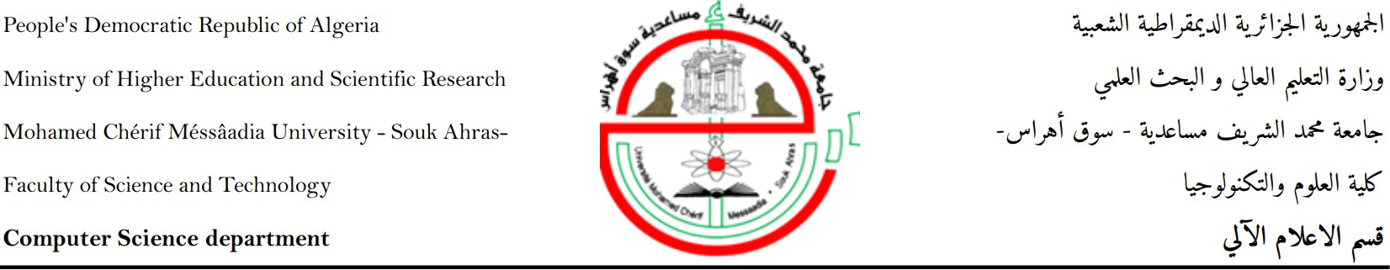

Year : **2024**

**A DISSERTATION**

Presented for obtaining the Master’s degree in Computer Science

**towards Artificial Intelligence-Based Adaptive E-learning systems in algerian education sector**

Darris Bi Dhakaa

Sector : **Computer Science**

Option :

**Software Engineering Realized by :**

**Touati seif eddine&Toured Lahcen Before the jury made up of :**

|  |  |  |  |  |
| --- | --- | --- | --- | --- |
| Mrs. | Aida BOUZID | President | MAA | *University of Souk Ahras* |
| Mrs. | Samia Drissi | Rapporteur | PR | *University of Souk Ahras* |
| Mr. | Djalel CHEFROUR | Co-Rapporteur | MCA | *University of Souk Ahras* |
| Mr. | Mohamed SOLTANI | Examiner | MAA | *University of Souk Ahras* |

**N°:...../ 2024**

## Dedicate

**Acknowledgements**

We express our profound gratitude to the Almighty for blessing us with the health and deter- mination to embark on and accomplish this report.

Foremost, we extend our heartfelt appreciation to our esteemed research director, *PR Samia Drissi*, for her invaluable guidance and unwavering support throughout the entirety of this endeavor. We are deeply grateful for her enlightened supervision, patience, and, above all, her confidence in our abilities. Her insightful remarks, invaluable advice, and accessibility have greatly enriched this work.

We also wish to extend our sincere thanks and appreciation to *PR Zakaria Gheid* for his invaluable insights and inspiration, which have contributed significantly to the development of this report.

We sincerely thank the members of the Discussion committee for assisting and judging our contest

A special note of gratitude goes to our beloved family members, whose boundless love, wise counsel, sacrifices, and unwavering encouragement have been the bedrock of our journey. Their steadfast support has empowered us to pursue our academic endeavors and, consequently, undertake the completion of this report.

To all those who have contributed to our journey, we offer our heartfelt thanks.



**Abstract**

During our internship, which took place in the Education Academy of the Wilaya of Souk Ahras and various educational institutions, we noted several shortcomings. To address the specific requirements of the education sector and provide innovative solutions, in this project, we designed and implemented a comprehensive framework called “Darris Bi Dhakaa,” composed of two parts: a web part and a mobile part.

The web part offers an Institutional Learning Management platform called *Moassassati* , which is considered the foundation of the project, and a Virtual Meeting Platform named *A3rad Darssek*.

The mobile part provides two main services: *3inek 3la Weldek* and *Saned Weldek*. *3inek 3la Weldek* is designed to keep parents informed and engaged in their child’s academic progress by providing real-time alerts and notifications. *Saned Weldek* is an AI-powered service aiming to assist students and their parents by offering personalized recommendations adapted to the Algerian educational context.

**Keywords:** Education sector, E-learning systems, Mobile systems, Artificiel Intelligence, recommandation systems ;

**Résumé**

Lors de notre stage qui s’est déroulé au sein de l’académie d’éducation de la wilaya de Souk Ahras et dans divers établissements d’enseignement, nous avons constaté plusieurs lacunes. Pour répondre aux exigences spécifiques du secteur algérien de l’éducation et apporter des solutions innovantes, dans ce projet, nous avons conçu et mis en œuvre un cadre complet appelé « Darris Bi Dhakaa » composé de deux parties, une partie web et une partie mobile. La partie web offre une plateforme de gestion de l’apprentissage institutionnel appelée *Moassassati* (), qui est considérée comme la base de notre projet, et une plateforme de réunion virtuelle dont le nom est *A3rad Darssek*. Par ailleurs, la partie mobile propose deux services principaux

: *3inek 3la Weldek* et *Saned Weldek*. *3inek 3la Weldek* est conçu pour tenir les parents informés et impliqués dans le progrès scolaire de leur enfant en fournissant des alertes et des notifications en temps réel. L’outil *Saned Weldek* est un service intelligent basé sur l’IA visant à assister les étudiants et leurs parents en fournissant des recommandations personnalisées adaptées au contexte éducatif algérien.

**Mots clés :** Secteur d’éducation, Systèmes de E-learning, Systèmes Mobiles, Intelligence artificielle.

# Contents

Dedicate iii

Summary in Arabic iv

Summary in English v

Summary in French vi

Contents x

List of Figures xi

List of Tables xiii

General Introduction 1

1. E-learning, M-learning & Existing Solutions 4

E-learning, M-learning & Existing Solutions 4

* 1. Introduction 4
  2. E-learning 4
     1. Definitions 4
     2. Learning mode 4
     3. Actors 5
  3. Mobile Learning 6
     1. Definitions 6
     2. M-learning vs. e-learning 6
     3. Importance of the Mobile Learning 7
  4. Existing Algerian Educational Application 9
     1. Al ibtidaia bayna yadayk 9
     2. “Top Academy” educational platform: 9
     3. Tabe3 Waldek 10
  5. Weak points of Existing Algerian Educational Application 11
  6. Conclusion 11

1. Recommendation Systems for Personalized Learning 12
   1. Introduction 12
   2. Definition of recommender systems 12
   3. Roles of RSs in E-learning 12
   4. Main classes of recommender systems 13
      1. Content-based filtering 13
      2. Collaborative filtering 13
      3. Hybrid systems 14
   5. Data Requirements and Pre-processing 14
   6. Data Pre-processing 14
   7. TF-IDF for content-based recommendations 14
   8. Conclusion 15
2. Design of Web Application Part 16
   1. Introduction 16
   2. Algerian Education Sector Needs 16
   3. Moassassati: Institutional Learning Management Platform 17
      1. Moassassati Specific Tools 17
      2. Flowchart of Moassassati System 18
         1. Student Management 18
         2. Teacher Management 18
         3. Course Management 20
         4. Room Assignments 20
         5. Room Management 20
         6. Examination Management 20
      3. Teachers Functional System Architecture 21
         1. Start and End Points 21
         2. Login Process 21
         3. Role Verification 21
         4. Teacher-Specific Functionalities 21
      4. Multi-tenant architecture of the Moassassati 23
         1. Authentication and Authorization Service 24
         2. User Management Service 24
         3. Notification Service 24
      5. Moassassati Use Case Diagram 25
         1. Global Use Cases 25
         2. Use case “General Management of the Platform” 27
         3. Use case “Create Educational Schools System” 27
         4. Use case “Create Accounts for School Administration” 27
         5. Use case “Create and Edit” (General Supervisor of the School) 27
         6. Use case “Create and Edit” (Teacher) 28
      6. Detailed Usage Schedule for Each Role 28
         1. Schedule for teacher 30
         2. Schedule for students 31
         3. Schedule for administration 32
      7. Use case diagram of Notify system 34
         1. User-Friendly Text Editor 34
         2. Message Customization 35
         3. Targeted Communication 35
         4. Scheduling and Delivery 35

CONTENTS

|  |  |  |
| --- | --- | --- |
|  | 3.3.7.5 Tracking and Analytics . . . . . . . . . . . . . . . . . . . . . . | 35 |
| 3.3.7.6 Security and Compliance . . . . . . . . . . . . . . . . . . . . . . | 36 |
| 3.4 A3radh Darssek Meeting Platform . . . . . . . . . . . . . . . . . . . . . . . . . . | 37 |
| 3.4.1 A3radh Darssek Use Case Diagram . . . . . . . . . . . . . . . . . . . . . | 37 |
| 3.4.1.1 Virtual Classrooms . . . . . . . . . . . . . . . . . . . . . . . . . | 37 |
| 3.4.1.2 Teacher Collaboration . . . . . . . . . . . . . . . . . . . . . . . | 38 |
| 3.4.1.3 Parent-Teacher Conferences . . . . . . . . . . . . . . . . . . . . | 38 |
| 3.4.1.4 Student Counseling . . . . . . . . . . . . . . . . . . . . . . . . . | 38 |
| 3.4.1.5 Administrative Coordination . . . . . . . . . . . . . . . . . . . | 39 |
| 3.4.2 Managing a Video Meeting . . . . . . . . . . . . . . . . . . . . . . . . . . | 39 |
| 3.5 Conclusion . . . . . . . . . . . . . . . . . . . . . . . . . . . . . . . . . . . . . . . | 41 |
| **4** | **Design of Mobile Application Part**  4.1 Introduction . . . . . . . . . . . . . . . . . . . . . . . . . . . . . . . . . . . . . . | **42**  42 |
|  | * 1. Mobile Part integration with Web Platform . . . . . . . . . . . . . . . . . . . .      1. Client Side (Mobile Application) . . . . . . . . . . . . . . . . . . . . . . | 43  45 |
|  | 4.2.2 Client Side (Web Application) . . . . . . . . . . . . . . . . . . . . . . . . | 45 |
|  | 4.2.3 Backend Services . . . . . . . . . . . . . . . . . . . . . . . . . . . . . . . | 45 |
|  | 4.2.4 Database . . . . . . . . . . . . . . . . . . . . . . . . . . . . . . . . . . . | 46 |
|  | 4.2.5 Communication and Integration . . . . . . . . . . . . . . . . . . . . . . . | 46 |
|  | 4.2.6 Security . . . . . . . . . . . . . . . . . . . . . . . . . . . . . . . . . . . . | 46 |
|  | 4.2.7 Adross Mobile Application Components . . . . . . . . . . . . . . . . . . | 47 |
|  | 4.3 3inek 3la Weldek . . . . . . . . . . . . . . . . . . . . . . . . . . . . . . . . . . . | 48 |
|  | 4.3.1 Its Purpose and Features . . . . . . . . . . . . . . . . . . . . . . . . . . . | 48 |
|  | 4.3.2 Flowchart for "3inek 3la Weldek" . . . . . . . . . . . . . . . . . . . . . . | 48 |
|  | 4.3.3 Strengths of "3inek 3la Weldek" tool . . . . . . . . . . . . . . . . . . . . . | 51 |
|  | 4.4 Saned Weldek . . . . . . . . . . . . . . . . . . . . . . . . . . . . . . . . . . . . . | 52 |
|  | * + 1. Recommendation Process in Saned Weldek . . . . . . . . . . . . . . . .     2. Process Breakdown . . . . . . . . . . . . . . . . . . . . . . . . . . . . . . | 52  55 |
|  | 4.4.2.1 Data Collection via Web Scraping . . . . . . . . . . . . . . . . . | 55 |
|  | 4.4.2.2 Form CSV . . . . . . . . . . . . . . . . . . . . . . . . . . . . . . | 55 |
|  | 4.4.2.3 Reload Every 24h . . . . . . . . . . . . . . . . . . . . . . . . . . | 55 |
|  | 4.4.2.4 Dataset . . . . . . . . . . . . . . . . . . . . . . . . . . . . . . . | 55 |
|  | 4.4.3 From Content-Based to Filtering and Behavior Analysis . . . . . . . . . | 58 |
|  | 4.4.4 Implementation and User Experience . . . . . . . . . . . . . . . . . . . . | 59 |
|  | 4.4.5 Advantages of Saned Weldek . . . . . . . . . . . . . . . . . . . . . . . . . | 59 |
|  | 4.5 Conclusion . . . . . . . . . . . . . . . . . . . . . . . . . . . . . . . . . . . . . . . | 60 |
| **5** | **Implementation And Development** | **61** |
|  | 5.1 Introduction . . . . . . . . . . . . . . . . . . . . . . . . . . . . . . . . . . . . . . | 61 |
|  | 5.2 “Darris Bi Dhakaa” Backend Implementation . . . . . . . . . . . . . . . . . . . | 61 |
|  | 5.2.1 “Moassassati” Backend Implementation . . . . . . . . . . . . . . . . . . . | 62 |
|  | 5.2.1.1 Infrastructures & Technologies . . . . . . . . . . . . . . . . . . | 62 |
|  | 5.2.1.2 Usage scenarios in “Moassassati” . . . . . . . . . . . . . . . . . | 67 |
|  | 5.2.1.3 Deploying . . . . . . . . . . . . . . . . . . . . . . . . . . . . . . | 76 |
|  | 5.2.2 “A3rad darssek” Backend Implementation . . . . . . . . . . . . . . . . . | 78 |
|  | 5.2.2.1 Infrastructures & Technologies . . . . . . . . . . . . . . . . . . | 78 |

5.2.2.2 Usage scenarios in “A3rad darssek” 79

* + 1. Programming Platform and Technology 85
    2. “Adross” Backend Implementation 86
       1. Adross App 86
       2. Adross Guardian App 88
    3. 3ink 3la Weldek Service 90
    4. Saned Weldek Services 93
       1. Web Scraping from DZ Exam and Ency-Education 93
  1. Conclusion 98
  2. Database Tables 100

**Conclusion** **106**

**Bibliography** **107**

# List of Figures

* 1. M-learning vs. e-learning 6
  2. Importance of the Mobile 7
  3. Al ibtidaia bayna yadayk 9
  4. “Top Academy” application interfaces 10
  5. Tabe3 Waldek interfaces 10
  6. Main classes of recommender systems 13
  7. TF-IDF Content-based Recommender System 15
  8. Flowchart of the Moassassati System 19
  9. Teachers Functional System Architecture 22
  10. Multi-tenant architecture 23
  11. Moassassati Use Case Diagram 26
  12. The schedule (Timetable chart and its types) 29
  13. Use case diagram of Notify system 34
  14. Use Case Diagram for A3radh Darssek Meeting Platform 37
  15. Managing a Video Meeting Process 39
  16. How Linking Mobile App, Web Application and various backend services 44
  17. Overview of Adross Mobile Application 47
  18. Flowchart of "3inek 3la Weldek" 50
  19. Saned Weldek Purpose 53
  20. Saned Weldek Purpose 54
  21. Flow Chart Of Web Scraping 57
  22. Darris Bi Dhakaa Platform 62
  23. Data base MySQL part 1 65
  24. Data base MySQL part 2 66
  25. Moassassati platform 67
  26. Interface of the login page for administrator 68
  27. Announcement 69
  28. Users role 69
  29. Students section 70
  30. Add new student 71
  31. Data saved 71
  32. list of Students 72
  33. Establish Test points 72
  34. Establish exam points 73
  35. platform -dash borad 74
  36. Permissions 75
  37. Scheduling for classes 76
  38. Hostinger’s hPanel for Moassasti platform 77
  39. Hostinger’s hPanel for Moassasti platform 77
  40. Next.js 78
  41. a3rad darsak login 80
  42. Clerk Dashboard 80
  43. A3rad darssek dash bord 81
  44. Meeting start 82
  45. Meeting schedule 83
  46. code for home page 84
  47. Adross Apps 86
  48. Adross app is designed for students 87
  49. Adross app is designed for students 88
  50. Adross Guardian app designed for parents 89
  51. Adross Guardian app designed for parents 89
  52. 3ink 3la Weldek Service 91
  53. Alerts and notifications system 92
  54. Web scraping code 93
  55. Data base from web scraping 94
  56. recommend system code 96
  57. Recommendations and notifications system 97
  58. Cours recommended 98

# List of Tables

* 1. Actors responsibilities 5
  2. Key benefits of mobile learning 8
  3. Table: session_years 100
  4. Table: lesson_topics 100
  5. Table: announcements 101
  6. Table: files 101
  7. Table: fee_paids 101
  8. Table: classrooms 102
  9. Table: academy_managements 102
  10. Table: student_account 102
  11. Table: promotions 102
  12. Table: notifications 103
  13. Table: subject_teachers 103
  14. Table: attendances 103
  15. Table: school_announcements 104
  16. Table: school_managements 104
  17. Table: feesclasses 104
  18. Table: subjects 105
  19. Table: trimesters 105

## General Introduction

Today, we are living in the era of technology, where technology has become a necessity for the continuation of society in all its fields, rather than just an additional means. Internet and ICT (Information and Communication technology) inonvations are at the forefront of these technological advancement.

Digitization which is one of the aspects of applying communication technology, and the trend toward it is increasing rapidly. By leveraging digitization of administrative tasks, educational institutions in Algeria can streamline operations, reduce paper work, and allocate more time and resources to teaching and learning activities ultimateling contributes to a more efficient and effective education system.

The digital revolution has radically transformed the way we learn and access information, enabling the development of new learning methods, such as e-learning an mobile learning. With the advent of e-learning and specifically mobile learning, the educational landscape has changed dramaticall where specifically, generation Z borning between 1997and 2012, is leading the way in this transformation.

As a result Mobile application are considered the most motivating way to learn something new, as they enable learning anytime and any where. Moreover, The possibility of peer-to- peer communication through mobile application provides students with a means of direct interaction, data exchange, and face-to-face cooperation. In addition mobile application allow for the addition of more engaging content, such as videos and audio, making the learning experience more interesting.

Personalized mobile and e-learning systems are effective in providing customized learning expe- riences to each learner, by adapting the learning content to the learners’ needs and progress. On the other hand, Artificial intelligence (AI) including machine learning (ML) and deep learning are powerful techniques that can enable personalized systems to analyze large amounts of data, learn from the learners’ behaviors and feedback, and generate optimal recommandations and interventions.

For transforming education and improving learning process in the Algerian educational con- text, our project aims firstly, to identify various educational needs in Algerian institutions, and secondly offer good quality solutions, and finally developing a comprehensive framework to rev- olutionize the Algerian education sector employing ICT inonvations and artificial intelligences technologies.

**Problematic and Motivation**

During our internship at the education academy of the Wilaya of Souk Shras and various edu- cational institutions including « Abou Mohadjer Dinar » institution, we have observed several shortcomings in the existing educational system that warrant the need for a comprehensive solution.

Firstly, the lack of an Institutional Learning Management System (ILMS) poses a significant challenge. Such a centralized platform is essential for managing academies and educational institutions with multiple levels, from primary to secondary schools. An ILMS would enable the effective delivery of educational content, tracking of student progress, and facilitation of communication between academies, different institutions, teachers, students, and parents.

Secondly, the weak digitization of administrative tasks, such as timetable preparation, exam scheduling, grades entry, reporting, and analytics, has resulted in inefficient and time- consum- ing processes. Streamlining these tasks through digital solutions can significantly improve the overall efficiency of educational institutions.

Moreover, the absence of robust communication, collaboration, and coordination channels be- tween teachers and students, parents and tecahers, and within the broader institutional com- munity has hindered effective information sharing and collaboration.

The manual student absences and attendance tracking system, coupled with the lack of robust alert systems for informing parents about student absences and attendance, poses challenges in monitoring and addressing student engagement and well-being.

Additionally, the absence of robust alert systems for informing parents about exam and test planning has limited their ability to support their children’s academic progress effectively.

Finally, the lack of assistance tools for resources (courses, tasks, tests, and exams) recommenda- tion, aligning with timetable and exam scheduling, and providing necessary support to parents and their children, has impacted the overall quality of the educational experience.

**Main contributions**

To resolve the identified shortcomings in Algerian educational system, our contribution consists in designing and implementing a comprehensive framework called *“darris bi dhakaa”*.

This framework is composed of two parts: web part and a mobile part. The web part of the framework offers an Institutional Learning Management System (ILMS) called *“Moassassati”*

, which serves as the core of the project. Moassassati provides a centralized platform for man- aging academies and educational institutions with multiple levels, from primary to secondary schools and facilitating communication between academies, institutions, teachers, students, and parents.

In addition to the ILMS, the web part also includes a Virtual Meeting Platform named *“A3rad Darssek”* offering a solution for virtual meetings tailored for the needs of teachers and educa- tional institutions.

The mobile part of the *“darris bi dhakaa”* framework provides two main services. The first

2

LIST OF TABLES

one is *“3inek 3la Weldek”* keeping parents informed in their child’s absences and attendance, exam results and dates and academic progress. And the second is *“Saned Weldek”* which is an AI-powered service assisting parents and students by providing them a set of recommendations of educational resources (courses, tasks, tests, and exams) tailored to the Algerian educational context.

**Report structure**

This research report is structured around five chapters they are structured as follows:

* The first chapter will focus on e-learning and mobile learning, their definition, and their actors while examining their advantages. Moreover, this chapter will cover the motivation for investing in the development of e-learning and mobile learning applications, as well as a critical evaluation of existing educational applications to identify key aspects that can be leveraged in the *“darris bi dhakaa”* framework and its power in leveraging intelligent solutions including personalized recommendation systems.
* The second chapter will give an overview of recommendation systems and explore their importance in the educational context.
* The third chapter will detail the design of the web part of Moassassati and *“A3rad Darssek”* platforms.
* The fourth chapter will dedicate to detail the design of the mobile part (Adross), with its two components *“3inek 3la Weldek”* and *“Saned Weldek”*.
* In the fifth chapter, we move to the implementation phase of the *“Moassasti”*, *“A3rad darssek”*, and *“Adross”* systems until we get the final product.

Chapter 1

## E-learning, M-learning & Existing Solutions

### Introduction

E-learning, or electronic learning, refers to the delivery of instructional content and learning experiences facilitated through the use of electronic technologies and digital platforms. On the other hand, students can now engage with educational content, collaborate with peers, and access just-in-time information anytime, anywhere, thanks to the portability and connectivity of their mobile devices.

This chapter takes a deeper dive into the world of e-learning and m-learning applications. By examining existing applications and analyzing these applications, we can identify the assets that are delivering value to the Algerian education sector, as well as any potential problems or pain points they may be encountering.

### E-learning

#### Definitions

“E-learning” or electronic Learning is an English term that translates literally to “electronic learning”.

There are several definitions for “e-learning” and consequently several terms used to refer to this concept, for example: “online training” (recommended in France), “online learning” (recommended in Canada) [1].

The European Commission has provided the following definition of e-learning: “E-learning is the use of new multimedia technologies and the Internet to improve the quality of learning by facilitating access to resources and services as well as remote exchanges and collaboration” [2].

#### Learning mode

As explored in [3], learning modes in e-learning systems present three learning modes:

4

* + - 1. **Synchronous mode**: Synchronous learning refers to any type of learning that takes place in real-time. It can happen through chat, web conferencing, or video conferencing.
      2. **Asynchronous learning**: Asynchronous learning does not happen in real-time. It al- lows students to access course materials and engage with content on their own schedule, without requiring simultaneous participation.
      3. **Blended learning**: Blended learning is a learning approach that combines face-to-face and distance learning experiences. Ideally, the two learning modes complement each other by leveraging the advantages of each approach [4].

#### Actors

In an e-learning environment, there are three main actors who are the administrator, the instructor, and the learner. Table 1.1 explains distinct roles for each one to support the overall learning process.

Table 1.1: Actors responsibilities

|  |  |
| --- | --- |
| **Actor** | **Roles** |
| Administrator | * Installing and maintaining the system, registering students and teachers. * Managing access and rights to educational re- sources. * Creating links to other systems and external re- sources (administrative files, catalogs, educational resources, etc.). |
| Instructor | * Author: Responsible for creating the content. * Tutor: Responsible for supporting the learners (monitoring and motivation). * Evaluator: Responsible for monitoring and evalu- ating the learner by creating knowledge validation activities and tests. * Advisor: Responsible for developing training plans and curricula for learners or groups of learners. |
| Learner | * The learner is the central actor for whom the train- ing is designed. * They can access the educational content, perform exercises, and participate in individual or collabo- rative learning activities. |

### Mobile Learning

#### Definitions

Mobile Learning (ML) can be defined as a learning environment in which students acquire information and knowledge from mobile devices [5].

#### M-learning vs. e-learning

Figure 1.1 presents a comprehensive overview of the key components and capabilities of an m-learning system within an e-learning context. The figure shows the key components of an m-learning system including:

* Mobile devices: various mobile devices that can be used for m-learning, such as smart- phones, tablets, PCs, and cell phones.
* Communication technology: includes communication technologies like GPRS, GSM, and Bluetooth that enable connectivity and data transmission between the mobile devices and the m-learning system.
* M-learning system: integrates the mobile devices, communication technologies, and var- ious types of information, such as learning materials, administrative information, and access options (on-campus, off-campus, online, and offline).
* Access modes: shows that the m-learning system allows for different access modes, in- cluding on-campus, off-campus, online, and offline.
* Synchronous and asynchronous communication: distinguishes between synchronous and asynchronous communication between students and teachers, highlighting the ability of the m-learning system to support various modes of learning.

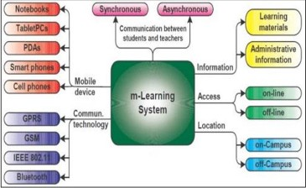

Figure 1.1: M-learning vs. e-learning

#### Importance of the Mobile Learning

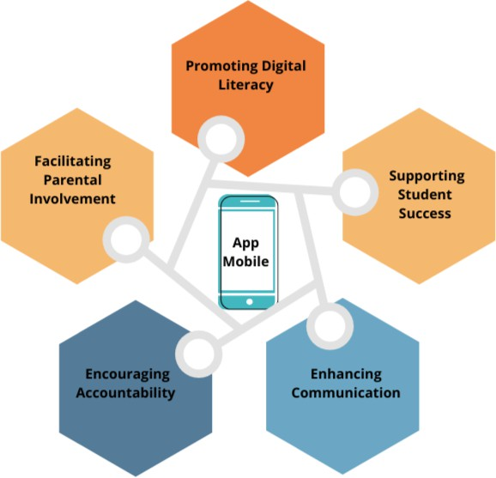

Figure 1.2: Importance of the Mobile

As mentioned in Figure 1.2, mobile learning leverages technology to promote digital literacy, enhance parental involvement, support student success, and improve communication between the school, students, and parents. Each benefit is explained in Table 1.2.

Table 1.2: Key benefits of mobile learning

|  |  |
| --- | --- |
| **Benefits** | **Explanation** |
| Promoting Digital Lit-  eracy | * Provides access to technology, helping students be- come familiar with digital tools and prepare for a technologically advanced world. * Offers access to a wide range of digital educational resources, such as e-books, online tutorials, and interactive learning modules. |
| Facilitating Parental  Involvement | * Sends real-time updates to parents about their child’s attendance, grades, and school announce- ments, enabling them to stay informed and in- volved. * Encourages parents to participate more actively in school activities and their child’s learning process. |
| Supporting Student  Success | * Utilizes AI-powered recommendations to provide personalized lesson plans and exam preparations based on each student’s unique learning needs. * Provides easy access to grades, attendance, and as- signment information, allowing students and par- ents to track academic progress and identify areas needing improvement. |
| Enhancing Communi-  cation | * Facilitates direct communication between parents and school staff, ensuring timely and effective ex- change of information. * Keeps families informed about school events, im- portant dates, and policy changes through instant notifications. |
| Encouraging Account-  ability | Provides a transparent view of a student’s academic per-  formance and school activities, promoting accountabil- ity among students, parents, and educators. |

### Existing Algerian Educational Application

#### Al ibtidaia bayna yadayk

“Al Ibtidaia Bayna Yadayk” is an educational platform designed specifically for primary school students in the Algerian market. It was created on September 8, 2019, by “Elbadri Apps”. The application is free and has been downloaded by more than 10,000 users. “Al Ibtidaia Bayna Yadayk” covers a wide range of learning resources and tools for primary school students in Algeria. As shown in Figure 1.3, it provides access to textbooks, summaries, and solved exercises, and offers homework assignments and exam preparations.

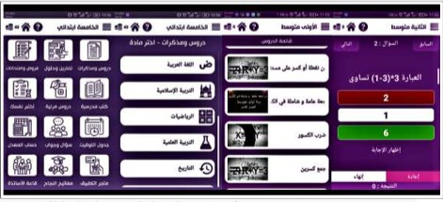

Figure 1.3: Al ibtidaia bayna yadayk

#### “Top Academy” educational platform:

“Top Academy” is an interactive educational platform designed for high school and middle school students in Algeria. The platform was created on October 7, 2019, by “MILESTONES SOLUTIONS”. It is a free application that has been downloaded by more than 10,000 users. “Top Academy” contains thousands of solved exercises for middle and high school levels, in- cluding multiple-choice questions, textbook lessons, and summaries. In addition, it offers time- specific assignments and tests to help students practice time management for exams. Moreover, it provides the “Agendati” function allowing students and parents to create a revision schedule, including setting the day, time, and duration of revision sessions.

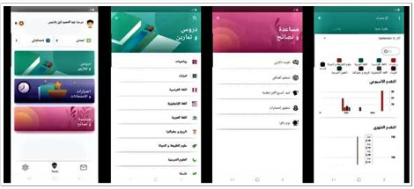

Figure 1.4: “Top Academy” application interfaces

#### Tabe3 Waldek

Tabe3 Waldek is an Android application implemented by master student of Souk Ahras Uni- versity in their report research, allowing parents to supervise their children’s progress in ele- mentary, middle and high school. Using this application, the parent would check from time to time and ask relevant questions at the appropriate time. it provides continuous assessment of the children.

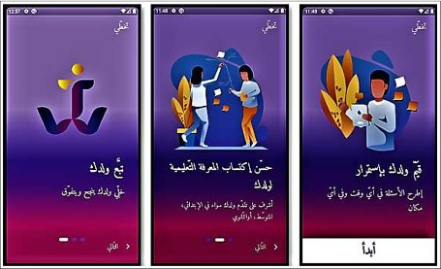

Figure 1.5: Tabe3 Waldek interfaces

### Weak points of Existing Algerian Educational Ap- plication

Despite these applications often offering course management and content delivery capabilities, they frequently lack the more comprehensive and integrated features including:

* Virtual Meeting Capabilities: these applications focus primarily on content hosting and distribution but may not provide robust virtual meeting functionalities tailored for the needs of teachers, students, and parents.
* Parent-Student Communication: these applications may provide limited parent-teacher communication channels.
* Personalized Recommendations: they focus on content delivery and management but do not offer personalized educational recommendations based on the student’s needs and performance.

### Conclusion

In this chapter, we have taken a deeper dive into the world of e-learning and m-learning appli- cations, addressing the lacunae in the existing solutions and meeting the evolving needs of the Algerian education sector. These needs can be addressed by leveraging a comprehensive integra- tion of web-based and mobile components, virtual learning tools, parent-school collaboration, and AI-powered personalized recommendations.

The next chapter will provide an overview of the applications of recommendation systems in the learning context.

Chapter 2

Recommendation Systems for Personalized Learning

### Introduction

Recommender systems (RSs), as used by Netflix, YouTube, or Amazon, are one of the most compelling success stories of AI. In the context of education and learning, recommender systems can provide tailored recommendations for educational content, learning activities, and resources that are optimized for each individual student’s needs and goals.

This chapter provides an overview of recommender systems, exploring their definitions and roles. It also examines the different recommender system techniques, including collaborative filtering, content-based filtering, and hybrid approaches, as well as the algorithms and models that power these systems.

### Definition of recommender systems

RSs are intelligent systems typically applying methodologies and techniques from the field of artificial intelligence, such as Machine Learning, to generate these personalized recommenda- tions [6].

RSs are used in various applications, including e-commerce, services, and advertising. RSs recommend items of greatest interest for users to focus their attention on [7] .

### Roles of RSs in E-learning

Recommender systems (RSs) play a crucial role in personalized content delivery and decision- making. Recommender systems are one of the most common software tools and techniques for providing users with personalized recommendations by predicting the preference (often expressed in a rating) that the users would give to an item [8].

12

### Main classes of recommender systems

Recommender systems are divided into different classes. One of the best-known taxonomies of recommender systems [9] divides algorithms into: As explained in Figure 2.1, the definition of each class is as follows:

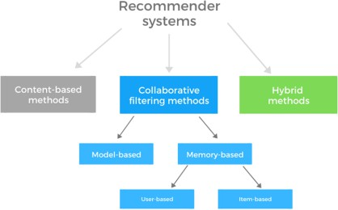

Figure 2.1: Main classes of recommender systems

#### Content-based filtering

Content-based filtering systems suggest items with characteristics similar to those with which the user interacted. In Content-based filtering algorithms, items are described by means of a set of explicit features. For instance, a movie can be characterized by genre, director, and list of actors. Such RSs tend to recommend items with the same characteristics as the movies a user "liked" in the past, thus they typically propose a limited variety of unexpected recom- mendations. One of the advantages of content-based recommendation is user independence – to make recommendations to a user, it does not require information about other users, unlike collaborative filtering. This makes content-based approach easier to scale. Another benefit is that the recommendations are more transparent, as the recommender can more clearly explain recommendation in terms of the features used.

#### Collaborative filtering

Collaborative filtering recommend items that other users with similar tastes have engaged with in the past. Collaborative filtering algorithms are based on collective preferences of the crowd, they recommend what similar customers bought or liked. Collaborative RSs are the most used, mainly because their implementation and integration in existing domains is relatively easy and their quality, in terms of objective metrics, is generally higher than CBF algorithms. There

Chapter 2. Recommendation Systems for Personalized Learning

are different types of Collaborative filtering methods, such as memory-based, model-based, and hybrid methods.

#### Hybrid systems

Hybrid systems rely on a combination of collaborative and content-based techniques for lever- aging the strengths of different methods [10].

### Data Requirements and Pre-processing

The success of recommender systems in educational applications depends on the availability and quality of the underlying data. Thus, recommender systems in e-learning require the following types of data:

* User Data: including user profiles (e.g., demographics, interests, learning styles), user interactions (e.g., course enrollments, resource views, quiz scores), and User feedback (e.g., ratings, reviews, comments)
* Item Data: Learning material metadata (e.g., title, description, keywords, difficulty level), Course information (e.g., learning objectives, topics, difficulty level) and Learning activity data (e.g., assignments, exercises, problem-solving tasks)
* Contextual Data: Time (e.g., timestamp of interactions, seasonality), location (e.g., de- vice, network, geographical location) and Learner behavior (e.g., learning pace, study patterns, time spent on activities)

### Data Pre-processing

Before using the data for recommender system development, it is important to preprocess the data to ensure its quality and consistency. The preprocessing steps include:

* Data Cleaning: consist of handling missing values, removing outliers and duplicates, normalizing and scaling numerical features
* Feature Engineering: aims to extract relevant features from raw data (e.g., text process- ing, sentiment analysis), creating new features based on domain knowledge (e.g., course prerequisites, topic hierarchy)
* Data Transformation: aims to encode categorical variables (e.g., one-hot encoding, la- bel encoding), handling temporal and contextual information (e.g., time-series analysis, geospatial data processing)

### TF-IDF for content-based recommendations

As shown in figure 2.2, the TF-IDF content-based recommender system steps are:

14

1. Feature Extraction: the technique TF-IDF is used to convert the textual course descrip- tions into numerical feature vectors. This allows quantifying the importance of each word in the descriptions and compare the courses based on their content.
2. Similarity Calculation: aims to calculate the cosine similarity between the feature vec- tors of all the courses. Cosine similarity is a common metric used in content-based recommender systems as it measures the angular distance between two vectors, which corresponds to the degree of similarity between the course descriptions.
3. Recommendation Generation: For a given course, we sort the other courses based on their similarity scores and return the top N most similar ones as recommendations.

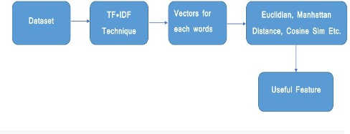

Figure 2.2: TF-IDF Content-based Recommender System

### Conclusion

By exploring RSs in this chapter, we can conclude that developing effective recommender systems for educational platforms requires a thoughtful approach to data management. As a result, the key to building a successful recommender system lies in the quality and relevance of the underlying data.

Chapter 3

Design of Web Application Part

### Introduction

After having explored the first two chapters of this report, the third chapter is dedicated to detailing the design of our comprehensive framework called “Darris Bi Dhakaa,” which is composed of two parts: a web part and a mobile part. Precisely, this chapter is dedicated to detailing the design of two important web application tools that are part of this framework: the Institutional Learning Management Platform called “Moassasti” and the A3rad darssek Meeting Platform. The designs of this framework and the proposed solutions have been developed based on the identification of various educational needs in Algeria, which were observed and documented during the completion of our internship.

### Algerian Education Sector Needs

During the completion of our internship, which took place in the education academy of the Wilaya of Souk Ahras and various educational institutions, we have noted several shortcomings as explained in the general introduction sections; the most important are the following:

* The need for an Institutional Learning Management System (ILMS) that provides a centralized platform for managing academies and educational institutions with multiple levels such as primary, middle, and secondary schools, delivering educational content, tracking student progress, and facilitating communication between teachers, students, and parents.
* Weak digitization on administrative tasks in Timetable Preparation, Exam Scheduling, and Grades Entry Reporting and Analytics.
* The absence of robust communication, collaboration, and coordination channels both between teachers and students, parents and students, and within the broader institutional community.
* Manual Student Absences and Attendance Tracking.

16

* The lack of robust alert systems for student absences and attendance for informing par- ents.
* The absence of robust alert systems for informing parents about exams and tests planning.
* The absence of assistance tools for resources (courses, tasks, tests, and exams) recommen- dation aligning with timetable and exam scheduling, and providing necessary support to parents and their children.

To resolve the identified shortcomings in the Algerian educational system, in our project we designed and implemented a framework called "Darris Bi Dhakaa.” This framework is composed of two parts: a web part and a mobile part. The web part offers an Institutional Learning Management platform called Moassassati which is considered the basis of the project, and a Virtual Meeting Platform whose name is "A3rad Darssek." Otherwise, the mobile part provides two main services: "3inek 3la Weldek" and "Saned Weldek.”

In the rest of this chapter, we will detail the design of the web application part with its two components: Moassassati and A3radh Darssek .

### Moassassati: Institutional Learning Management Plat- form

Moassassati is a comprehensive web-based application designed for the education sector. It is considered the basis of the project as we relied on it for the rest of the services. It provides a control panel with a comprehensive suite of administrative tools designed to streamline the management of educational institutions, including both public and private schools. Moreover, Moassassati plays a crucial role in facilitating communication between academies and their affil- iated educational institutions. It also provides many auxiliary tools for Schedule Management, Timetable Creation, and Attendance Tracking. Moassassati has a highly sophisticated permis- sion system that allows different administrative members to manage and organize individuals based on their roles and responsibilities within the organization.

#### Moassassati Specific Tools

The Institutional Learning Management Platform “Moassassati” offers many tools includ- ing:

* **Permissions Tool:** The permissions tool in Moassassati allows administrators to assign specific permissions to individual users or groups of users based on their roles and re- sponsibilities in the educational institution. In Moassassati, permissions can be assigned based on predefined roles such as teacher, student, parent, administrator, or other custom roles created by the institution.
* **Authentication Tool:** Educational institutions have the autonomy to manage their user accounts, including creating, editing, and deleting accounts for teachers, students, parents, and administrators. Users can log in to the Moassassati platform using their email address and date of birth as authentication credentials.
* **Educational Schedule Tool:** This tool uses a user-friendly interface allowing authorized personnel to create and manage the daily schedule for teachers and students in each section of the educational institution. Upon completion, the schedule is automatically sent to teachers and students via email or other notification methods.
* **Classes Management Tool:** Using this tool, the administrator can add, consult, mod- ify, and delete a class if necessary.
* **Modules Management Tool:** Using this tool, the administrator can create, view, modify, and delete a module if necessary.
* **Specialities Management Tool:** The administrator can add, consult, modify, and delete a speciality if necessary.
* **Alerts System and Message Sending System:** The system allows administrators to send alerts and messages to specific students or teachers. In addition, this system can allow each academy to send messages and alerts to all educational institutions or to a single educational institution.
* **Communication System:** This system facilitates communication between teachers within the same educational institution. Teachers can communicate with the admin- istration or with other teachers through the system by sending absence requests or chat. Also, parents can contact teachers and the administration directly through the system.

#### Flowchart of Moassassati System

To represent the overall flow of the Moassassati system, a flowchart diagram is used as a visual representation of a process. Flowchart diagram uses standardized symbols and connecting lines including inputs, outputs, and major processing steps to illustrate the sequence of steps, decision points, and data flow. A complete diagram of the Moassassati system is shown in Figure 3.1.

As mentioned in the figure 3.1, the Flowchart of Moassassati System is divided into five major functional areas: **Student Management, Teacher Management, Course Management, Timetable Management**, and **Examination Management**.

##### Student Management

The student management flowchart provides a clear and concise representation of the key processes involved in managing student data and activities. It focuses on handling student- related activities as follows:

* + - * + **Enrollment**: the process of admitting students into the school.
        + **Grades & Records**: managing students’ academic performance records.
        + **Student Profiles**: creating and maintaining comprehensive profiles for each student.

##### Teacher Management

The teacher management flowchart deals with teacher-related activities including:

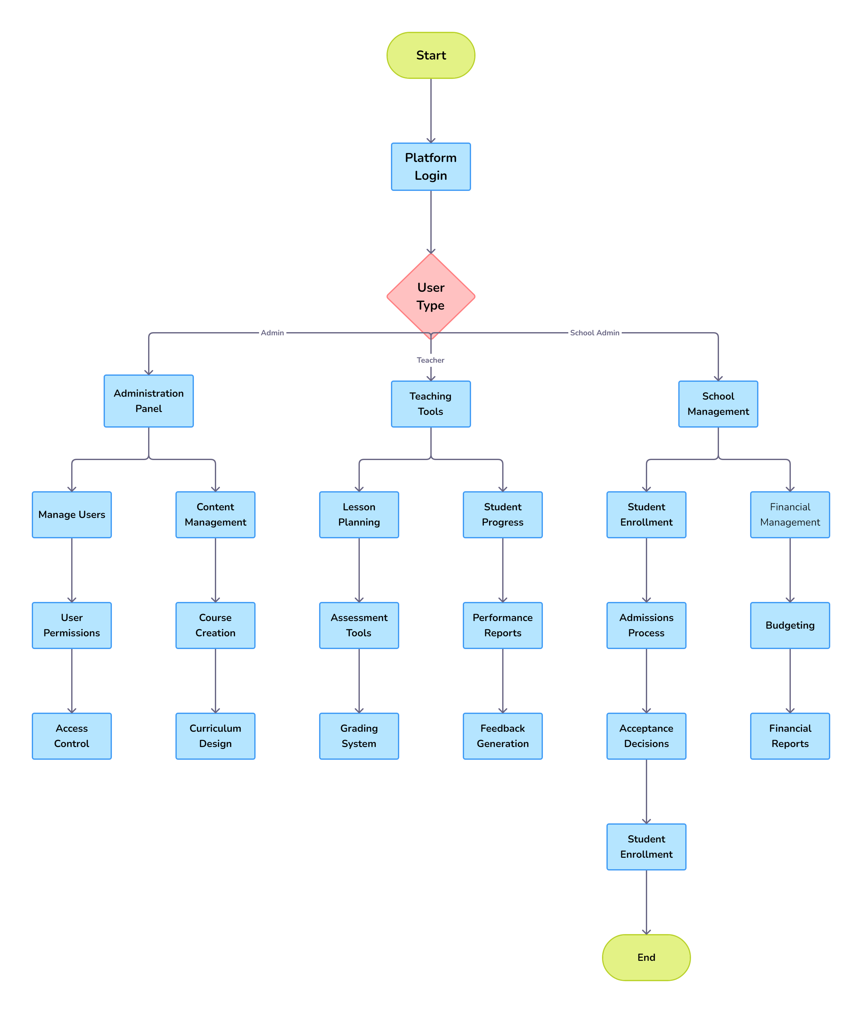

Figure 3.1: Flowchart of the Moassassati System

* + - * + **Schedule Allocation**: assigning teaching schedules to teachers.
        + **Qualifications**: managing and verifying teachers’ qualifications and credentials.

##### Course Management

Course management flowchart centred on managing courses offered by the school. It can in- clude:

* + - * + **Course Creation**: the process of creating new courses.
        + **Course Enrollment**: enrolling students into courses.
        + **Course Catalog**: maintaining a catalog of all available courses.

##### Room Assignments

This component deals with allocating appropriate classrooms for the scheduled classes. The process aims to assigning rooms to classes while considering factors like room availability and accessibility.

##### Room Management

Room Management functionality deals with managing and maintaining classrooms.

##### Examination Management

The examination management flowchart demonstrates the interconnected nature of exam schedul- ing, grades entry, and transcript management work together to ensure the effective administra- tion of the school’s examination process in the following way:

* + - * + **Exam Scheduling**: Planning and scheduling examinations.
        + **Grades Entry**: Entering and managing examination grades.
        + **Transcripts**: Generating and maintaining academic transcripts for students.

The workflow integration between Time Table Management, Room Management, and Exam Timetable modules in the Moassassati system ensures that the overall timetable, room utiliza- tion, and exam administration are effectively coordinated and managed. This integration helps to optimize the use of resources, minimize conflicts, and provide a seamless experience.

* + - * + **Timetable Management**: Both the Teacher Management and Timetable Management modules contribute to the creation of a comprehensive timetable.
        + **Room Management**: Ensures that the allocation of rooms is effectively managed across different modules.
        + **Exam Timetable**: Combines exam scheduling with room assignments to create an exam timetable.

As shown above in figure 3.1, the overall flow of processes demonstrates the interconnected nature of the various modules within the Moassassati system. Each module relies on the inputs

and outputs of the other modules to ensure a seamless and efficient academic administration experience. These processes are ordered as following:

* + - * + The process starts from the Start point.
        + Student Management processes (Enrollment, Grades & Records) lead to the creation of Student Profiles.
        + Teacher Management (Teacher Profiles, Schedule Allocation) and Course Management (Course Creation, Course Enrollment) create a timetable.
        + Timetable Management (Schedule Creation, Room Assignments) integrates with Room Management to ensure proper allocation and scheduling.
        + Examination Management (Exam Scheduling, Grades Entry) leads to the generation of Exam Timetables and Transcripts.

#### Teachers Functional System Architecture

Figure 3.2 shows the start and end points, as well as the key steps in the teacher-specific login and functionality processes within the Moassassati system as follows:

##### Start and End Points

**Start point** is the initiation point where the process begins while **End point** signifies the completion of the process flow.

##### Login Process

Teachers start by logging into the platform. This step is crucial for accessing the system and its functionalities.

##### Role Verification

The role verification process goes through these stages:

* + - * + **Role Check**: after logging, the first step is to verify the user’s role to determine if they are a teacher or not.
        + **Teacher**: if the user is identified as a teacher, he is granted access to the teacher-specific dashboard.
        + **Not teacher**: if the user is not a teacher, access is denied, and he can not proceed further in this workflow.

##### Teacher-Specific Functionalities

Once the user is verified as a teacher, he has access to several key functionalities through his dashboard. The dashboard serves as the central hub for teachers, providing them with access to various management and instructional tools including:

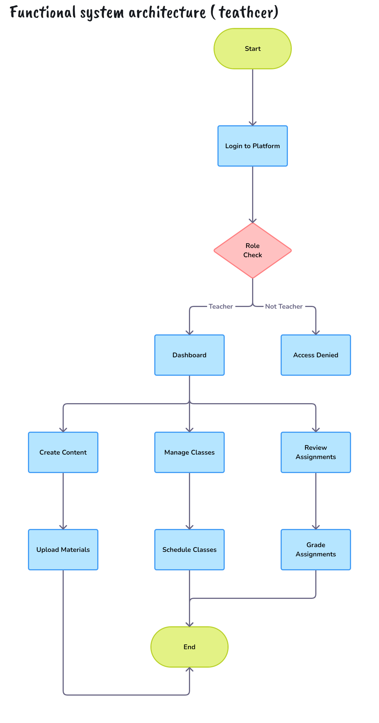

Figure 3.2: Teachers Functional System Architecture

* + - * + **Create Content**: teachers can create and upload educational materials, such as lesson plans, presentations, and other resources for their classes.
        + **Manage Classes**: this functionality allows teachers to schedule classes, including setting dates, times, and possibly assigning rooms or virtual meeting links.
        + **Review Assignments**: teachers can review student submissions and grade assignments. This process includes providing feedback and recording grades.

The architecture presented in Figure 3.2 ensures that teachers have a streamlined process for accessing and managing their educational responsibilities. This architecture summarizes the following Key benefits including:

* + - * + **Security**: Ensuring that only authorized teachers can access the platform’s teaching functionalities.
        + **Efficiency**: Providing a centralized dashboard for easy management of classes, content creation, and grading.
        + **Flexibility**: Allowing teachers to upload materials, schedule classes, and review assign- ments, thereby supporting their instructional needs effectively.

#### Multi-tenant architecture of the Moassassati

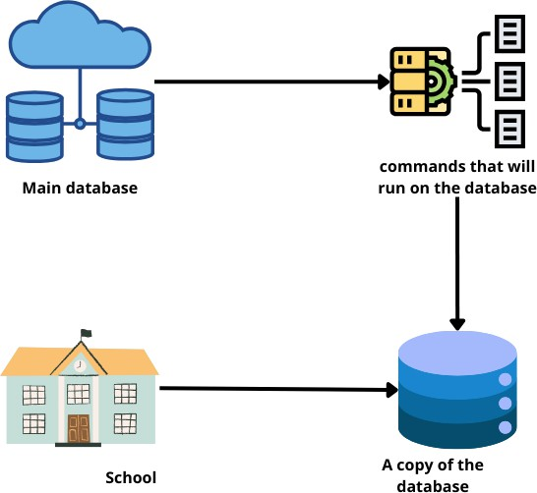

Figure 3.3: Multi-tenant architecture

Moassassati platform is designed as multi-tenant architecture where each school operates with its own isolated database to store student records, curriculum content, and other school-specific

data. The data isolation ensures data privacy, integrity, and effective platform-level manage- ment. Additionally, there is a central master database for high-level oversight and management. The multi-tenant architecture ensures that changes or updates in one school’s database do not affect others, while allowing the central administration to maintain a global view of all activi- ties.

##### Authentication and Authorization Service

The authentication and authorization service is a critical component of the Moassassati plat- form’s multi-tenant architecture. This service works as follows:

* + - * + **Role-Based Access Control (RBAC)**: the Moassassati platform employs a robust RBAC system to manage user access and permissions where each user is assigned a specific role, such as school administrator, teacher, or student, which determines their level of access and the data they can view or interact with. So, the TRBAC model ensures that users can only access data and functionality that is relevant to their assigned role and the school they are associated with.
        + **Single Sign-On (SSO)**: SSO provides a seamless user experience where users can au- thenticate once and then access the various services and databases on the platform without needing to re-enter their credentials.

##### User Management Service

The user management service is an important aspect of the Moassassati platform’s multi- tenant architecture ensuring own independent user management capabilities and maintaining a centralized view and management capabilities for all users across the platform basing on:

* + - * + **School-Level User Management**: Each school manages its own users independently.
        + **Centralized Admin Oversight**: The central administration can view and manage users across all schools without interfering with local operations.

##### Notification Service

To maintain the autonomy and control that each school has over its own operations and com- munication with teachers, students, parents and other actors, Moassassati platform’s integrates notification service including:

* + - * + **Localized Notifications**: notifications about attendance, grades, etc., are handled lo- cally meaning that notifications are generated and managed within the individual school’s database.
        + **Centralized Policy Notifications**: important policy updates and global notifications are sent from the central database.

By implementing these multi-tenant services and data isolation mechanisms, the Moassassati platform aims to provide a secure, scalable, and flexible solution for educational institutions, while maintaining the necessary data privacy and integrity for each participating school. More- over, with these services our platform is able to balance the autonomy and control of individual

schools while also ensuring consistent and effective communication of important platform-wide policies and updates.

#### Moassassati Use Case Diagram

A use case represents a series of sequences of actions performed by the system in a scenario and producing an observable result of interest to a particular actor. It models a service provided by the system. It expresses the actor/system interactions and brings added value to the actor concerned.

##### Global Use Cases

The Moassassati use case diagram captures the hierarchical structure and the interactions between the different actors and the system’s functionalities. As mentioned previously, each actor has specific roles and responsibilities, and the use cases demonstrate how these roles contribute to the overall management and operation of educational institutions within the platform.

Figure 3.4 provides the additional details on the various actors within the Moassasati as cap- tured in the use case diagram as follows:

* + - * + **Platform Management**: This actor represents the administrators responsible for the overall management of the platform.
        + **Academy Administration**: This actor represents the administrative body of individual academies within the system.
        + **The School Administration**: This actor represents the administrative body of indi- vidual schools within an academy.
        + **The General Supervisor of the School**: This actor represents the individuals who supervise the operations of a school.
        + **The Teacher**: This actor represents the educators who are responsible for teaching and managing their classrooms.

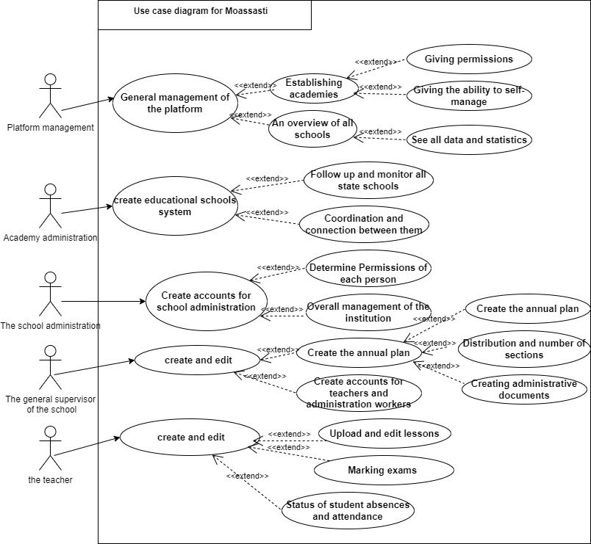

Figure 3.4: Moassassati Use Case Diagram

##### Use case “General Management of the Platform”

The "General Management of the Platform" use case is designed to accommodate the multi- layered nature of the educational ecosystem empowering individual academies and schools with the necessary autonomy and self-management capabilities as outlined below:

* + - * + **Establishing Academies**: extends the general management function by allowing the creation of new academies.
        + **Giving Permissions**: further extends establishing academies to assign specific roles and permissions within the academy.
        + **An Overview of All Schools**: extends the general management function by providing a summary view of all schools in the platform.
        + **Giving the Ability to Self-Manage**: further extends the overview to allow schools some level of autonomy.
        + **See All Data and Statistics**: provides detailed data and statistics for better decision- making.

##### Use case “Create Educational Schools System”

"Create Educational Schools System" use case allows the Academy Administration to:

* + - * + **Follow Up and Monitor All State Schools**: extends the creation of the school system by tracking the performance and activities of state schools.
        + **Coordination and Connection between Them**: ensures that there is a streamlined communication and coordination among all schools.

##### Use case “Create Accounts for School Administration”

"Create Educational Schools System" use case allows the School Administration to:

* + - * + **Determine Permissions of Each Person**: extends the account creation process to assign specific roles and permissions to different users.
        + **Overall Management of the Institution**: involves managing the school administra- tion comprehensively.
        + **Create the Annual Plan**: extends overall management to include planning for the academic year.
        + **Distribution and Number of Sections**: further extends the annual planning to orga- nize the sections and classes within the school.

##### Use case “Create and Edit” (General Supervisor of the School)

“Create and Edit” use case allows the General Supervisor of the School to:

* + - * + **Create Accounts for Teachers and Administration Workers**: extends the creation process to include setting up accounts for teachers and administrative staff.
        + **Create the Annual Plan**: extends the creation process to include planning the academic year.
        + **Creating Administrative Documents**: includes the creation of necessary administra- tive documents.

##### Use case “Create and Edit” (Teacher)

«Create and Edit» use case allows teachers to:

* + - * + **Upload and Edit Lessons**: extends the creation and editing function to include man- aging lesson content.
        + **Marking Exams**: extends the creation and editing function to include grading student exams.
        + **Status of Student Absences and Attendance**: extends the function to include track- ing and recording student attendance.

#### Detailed Usage Schedule for Each Role

As shown in Figure 3.5, the Timetable Management tool is a crucial component of the Moassas- sati system, as it outlines the process for creating and managing timetables for administration, teachers, and students.

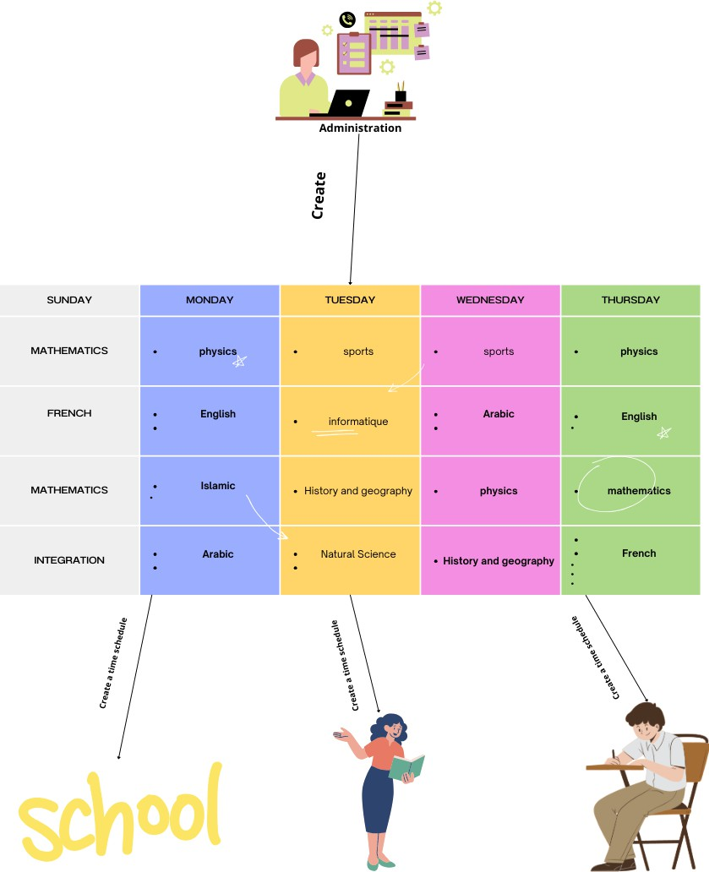

Figure 3.5: The schedule (Timetable chart and its types)

##### Schedule for teacher

The teacher schedule outlines the essential tasks (daily, weekly, and monthly tasks) and respon- sibilities that teachers must perform in the following ways:

* + - * + **Daily Tasks are guaranteed by**:

**Login to Platform**: start the day by logging into the school management system.

**Create and Upload Lesson Plans**: prepare lesson plans and upload materials for the day’s classes.

**Conduct Classes**: engage with students in scheduled classes, both online and offline.

**Review Assignments**: check and provide feedback on assignments submitted by students.

**Grade Assignments**: assign grades to student submissions and record them in the system.

**Update Attendance**: record student attendance and monitor absences.

**Parent Communication**: respond to queries from parents and provide updates on student progress.

* + - * + **Weekly Tasks are guaranteed by**:

**Schedule Classes**: plan the timetable for the upcoming week.

**Collaborate with Colleagues**: attend meetings and collaborate with other teach- ers for curriculum planning.

**Professional Development**: participate in training sessions and workshops for skill enhancement.

**Student Performance Review**: analyze student performance data and identify areas for improvement.

* + - * + **Monthly Tasks are guaranteed by**:

**Progress Reports**: prepare and submit student progress reports.

**Curriculum Review**: review and adjust the curriculum based on student perfor- mance and feedback.

**Parent-Teacher Meetings**: schedule and conduct meetings with parents to discuss student progress.

##### Schedule for students

The schedule for students ensures they follow a structured learning path, stay engaged, and complete their academic requirements on time. It presents through:

* + - * + **Daily Tasks which are guaranteed by**:

**Login to Platform**: start the day by logging into the school management system.

**Attend Classes**: participate in scheduled online or offline classes.

**Complete Assignments**: work on and submit daily assignments.

**Study and Review**: spend time studying the day’s lessons and reviewing notes.

**Engage in Extracurricular Activities**: participate in sports, clubs, and other extracurricular activities.

**Check Notifications**: stay updated with announcements and notifications from teachers and administration.

* + - * + **Weekly Tasks which are guaranteed by**:

**Plan Study Schedule**: organize a study schedule for the upcoming week.

**Group Study Sessions**: collaborate with peers for group study sessions.

**Progress Check**: review academic progress and seek help if needed.

**Library Time**: allocate time for reading and research in the library.

* + - * + **Monthly Tasks which are guaranteed by**:

**Exams and Assessments**: prepare for and take monthly exams or assessments.

**Project Work**: work on and submit long-term projects.

**Parent Meetings**: attend meetings with parents and teachers to discuss progress.

**Extracurricular Projects**: engage in larger extracurricular projects or events.

##### Schedule for administration

The schedule for the administration focuses on maintaining the overall functionality of the school, supporting teachers, and ensuring a smooth operation. It presents through:

* + - * + **Daily Tasks which are guaranteed by**:

**Login to Platform**: start the day by logging into the school management system.

**Monitor Attendance**: check and record attendance for students and staff.

**Manage Schedules**: oversee the daily schedule of classes, events, and meetings.

**Respond to Inquiries**: handle inquiries from parents, students, and teachers.

**Update Records**: keep student and staff records up-to-date.

**Facility Management**: ensure all school facilities are in proper working condition.

* + - * + **Weekly tasks which are guaranteed by**:

**Staff Meetings**: conduct weekly staff meetings to discuss progress and address issues.

**Financial Management**: review and manage the school’s finances, including bud- get allocation.

**Report Generation**: generate reports on attendance, performance, and other metrics.

**Communication with Authorities**: liaise with education authorities and regu- latory bodies.

* + - * + **Monthly tasks which are guaranteed by**:

**Performance Review**: conduct performance reviews for teachers and staff.

**Policy Review**: review and update school policies and procedures.

**Event Planning**: plan and organize school events, such as sports days, cultural events, and parent-teacher meetings.

**Inventory Management**: check and replenish school supplies and resources.

By implementing these detailed usage schedules, the educational institution can ensure that all roles and departments operate efficiently and collaboratively, ultimately leading to a more effective and harmonious learning environment.

* + - * + **Improved Efficiency**: clearly defined schedules help streamline tasks and improve effi- ciency.
        + **Enhanced Coordination**: ensures all departments and roles are aligned and work col- laboratively.
        + **Better Time Management**: helps individuals manage their time effectively and prior- itize tasks.
        + **Increased Accountability**: clearly defined responsibilities ensure accountability at all levels.
        + **Enhanced Learning Experience**: provides a structured environment for students, leading to better academic outcomes.

#### Use case diagram of Notify system

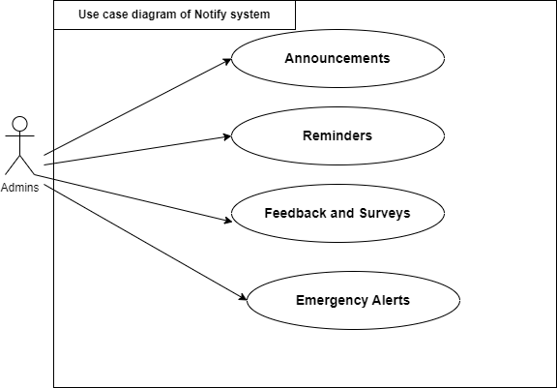

Figure 3.6: Use case diagram of Notify system

We remind that the Moassassati platform includes a comprehensive messaging system, playing a crucial role in facilitating effective communication among the various stakeholders, includ- ing academics, educational institutions, and students. The Moassassati messaging system is characterized by several strong points:

##### User-Friendly Text Editor

The messaging system is equipped with a robust text editor that provides flexibility and func- tionality for creating and formatting messages in a professional manner. This editor can sup- port:

* + - * + **Rich Text Formatting**: the text editor supports rich text formatting, allowing the admin to use bold, italics, underline, bullet points, numbered lists, and other text styling options. This ensures that messages are clear and visually appealing.
        + **Advanced Formatting Options**: the editor includes advanced formatting features such as font selection, text color changes, background colors, and alignment options (left, center, right, and justified).
        + **Hyperlinks and Multimedia**: Admins can insert hyperlinks to direct recipients to relevant websites or resources. Additionally, they can embed images, videos, and other multimedia elements to make the messages more engaging and informative.

##### Message Customization

The messaging system provides message customization capabilities to leverage templates and personalization features. These customization options can use:

* + - * + **Templates**: the platform allows the creation and use of templates for common types of messages as needed.
        + **Personalization**: messages can be personalized using placeholders that automatically fill in specific information such as the recipient’s name, course details, or institution name. This personal touch enhances the relevance and impact of the communication.

##### Targeted Communication

The Moassassati platform’s messaging system has the ability to leverage targeted communi- cation and audience segmentation. This capability plays a role in ensuring that messages are delivered to the right stakeholders, maximizing the impact and relevance of the communication. These features are guaranteed through:

* + - * + **Recipient Selection**: administrators can select specific groups or individual recipients for their messages. This could include all students in a particular course, all academics within a department, or specific educational institutions.
        + **Segmentation**: The system allows for segmentation based on various criteria such as academic role, course enrollment, institution type, and more. This ensures that messages are sent to the appropriate audience.

##### Scheduling and Delivery

The Moassassati messaging system offers scheduling and delivery capabilities, providing admin- istrators with the flexibility and control they need to effectively manage their communications. These capabilities are managed as follows:

* + - * + **Scheduling**: the ability to schedule messages for future delivery is a valuable asset for administrators to plan and automate their communications. This asset is useful for sending reminders, updates, or important announcements at optimal times.
        + **Instant Delivery**: for urgent communications, messages can be sent instantly to ensure timely delivery of critical information.
      1. **Tracking and Analytics**

Tracking and analytics capabilities are offered by the Moassassati messaging system includ- ing:

* + - * + **Read Receipts**: this functionality allows administrators to track when their messages are opened and read by the intended recipients.
        + **Analytics**: administrators can access detailed analytics on message delivery rates, open rates, and recipient engagement.
      1. **Security and Compliance**

The messaging system places a strong emphasis on security and compliance, ensuring that all communication activities adhere to:

* + - * + **Data Privacy**: The messaging system is designed with data privacy in mind, ensuring that all communications comply with relevant data protection regulations.
        + **Secure Messaging**: Messages are sent through secure channels to protect the confiden- tiality and integrity of the information.
  1. **A3radh Darssek Meeting Platform**

After having detailed the design of the first component of the web part, which is the Institu- tional Learning Management platform Moassassati, we will now explore and detail its second component called A3radh Darssek Meeting Platform.

* + 1. **A3radh Darssek Use Case Diagram**

The figure 3.7 shows a use case diagram for A3radh Darssek meeting platform. The diagram depicts that the teacher interacts with the "Meeting Management" use case, which includes the following sub-use cases: Handles scheduling, Managing participant lists, and Starting and ending meetings.

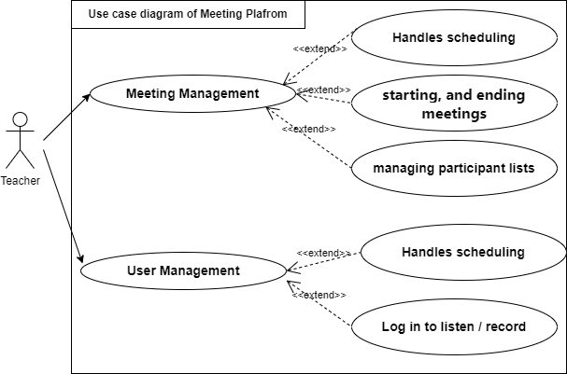

Figure 3.7: Use Case Diagram for A3radh Darssek Meeting Platform

A3radh Darssek Meeting Platform offers a comprehensive solution for virtual meetings tailored for the needs of teachers and educational institutions. This platform provides robust tools for virtual classrooms, collaboration, counseling, and administrative coordination.

* + - 1. **Virtual Classrooms**

The virtual classroom capabilities of the A3radh Darssek meeting platform enable teachers to conduct live, interactive learning sessions with their students remotely. The virtual classrooms include:

* + - * + **Conduct live lectures and interactive sessions with real-time video and audio streaming.**
        + **Use breakout rooms to facilitate group discussions and collaborative projects.**
        + **Implement polls and Q&A sessions to engage students and gather instant feedback.**
      1. **Teacher Collaboration**

The collaborative dimension of the A3radh Darssek meeting platform enables teachers to en- gage in various collaborative activities, leveraging the platform’s features to enhance their professional development by:

* + - * + Hosting staff meetings to discuss administrative matters, curriculum development, and school policies.
        + Participating in professional development workshops and training sessions to enhance teaching skills.
      1. **Parent-Teacher Conferences**

Parent-Teacher Conferences enable teachers to schedule and conduct private, one-on-one meet- ings with parents to discuss student progress and address any concerns through:

* + - * + Scheduling and conducting one-on-one meetings with parents to discuss student progress and address concerns.
        + Using secure and private channels to ensure confidentiality during these important dis- cussions.
      1. **Student Counseling**

Student Counseling aims to provide comprehensive support to students, addressing their aca- demic, personal, and developmental needs in a secure and engaging virtual environment by:

* + - * + Offering personalized guidance and support through one-on-one virtual counseling ses- sions.
        + Conducting group counseling sessions focusing on common issues such as exam prepara- tion and career guidance.
      1. **Administrative Coordination**

Administrative Coordination enables school administrators to coordinate various school-wide activities including:

* + - * + Coordinating school events, planning schedules, and discussing policy changes in virtual meetings.
        + Facilitating committee meetings to discuss specific topics like curriculum changes.
    1. **Managing a Video Meeting**

Figure 3.8 represents the process for creating and managing a video meeting on the A3radh Darssek Meeting Platform. This process goes through the following stages:

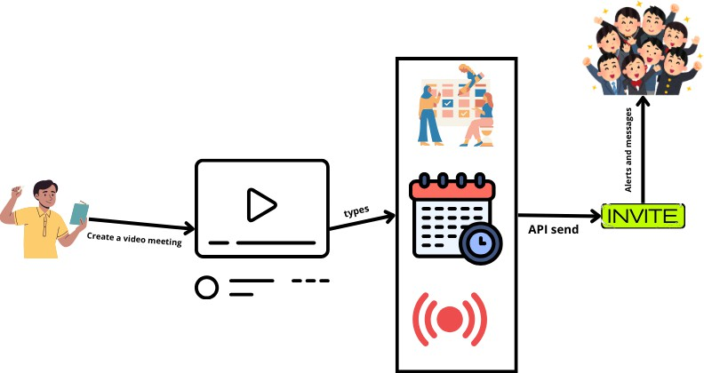

Figure 3.8: Managing a Video Meeting Process

1. **Initiation by Teacher**:
   * **Action**: The teacher initiates the process by creating a video meeting. This could be for a class, meeting with parents, or a collaboration session with colleagues.
   * **Representation**: The teacher is illustrated on the left side, holding a device to initiate the meeting.
2. **Creating a Video Meeting**:
   * **Action**: The teacher uses the platform’s interface to set up a new video meeting. This involves specifying details such as the meeting title, description, date, time, and participants.
   * **Representation**: This step is visually represented by a video play icon, indicating the setup of the video meeting.
3. **Selecting Meeting Type**:
   * **Action**: The details of the meeting, including its type (e.g., lecture, discussion, parent-teacher conference), are entered into the system. This categorization helps in organizing and managing meetings more effectively.
   * **Representation**: An arrow labeled "types" points to a section that symbolizes different types of meetings and scheduling options.
4. **Scheduling and Management**:
   * **Action**: The platform schedules the meeting based on the provided details. This includes adding the meeting to the calendar, setting reminders, and preparing for the meeting start and end times.
   * **Representation**: This is depicted by a calendar with a clock and icons representing different activities (e.g., scheduling, managing participants, and sending reminders).
5. **API Send**:
   * **Action**: The platform uses an API (Application Programming Interface) to send out invites to the intended participants. The API ensures that the invites are sent securely and reliably to all participants.
   * **Representation**: An arrow labeled "API send" leads to the next step, showing the integration and automation of the invite process.
6. **Invite**:
   * **Action**: Participants receive alerts and messages inviting them to the meeting. These alerts can be in the form of emails, push notifications, or SMS, depending on the system’s configuration and the participants’ preferences.
   * **Representation**: The "INVITE" box highlights this action, with arrows pointing to a group of excited participants, symbolizing the reception of the meeting invitations.
   1. **Conclusion**

To address the specific requirements of the education sector and providing innovative solutions, throughout this chapter, we have presented a comprehensive overview of the web part with its two components: Moassassati platform and A3radh Darssek Meeting Platform as a robust solution designed to cater to the diverse needs of the algerian education sector.

The Moassasti platform offers various services including time table management which can effectively manage the complex scheduling requirements of any educational institution and deliver a consistent and high-quality educational experience for all stakeholders. On the other hand, A3radh Darssek Meeting Platform emerges as a transformative platform that empowers educational institutions to enhance virtual collaboration, improve administrative efficiency, and deliver personalized support to students, ultimately contributing to the overall success and growth of the educational ecosystem.

Chapter 4

Design of Mobile Application Part

* 1. **Introduction**

After having completed the design of the web part of our comprehensive framework “Darris Bi Dhakaa, This fourth chapter is dedicated to detailing the mobile part (Adross) as a seam- less extension of our comprehensive web framework. By integrating with our established web platform, Adross ensures a streamlined experience, allowing users to navigate between mobile and desktop environments. In this chapter, we explore two important tools, the first tool is "3inek 3la Weldek" and the second is "Saned Weldek”. In more detail, after exploring various goals of Adross Mobile Application, we show how mobile application, web application, and various backend services are integrated, interacted and workek together. After that, we detail the design of “3inak 3la Weldek" and "Sanad Weldek" tools .

**Goals of Adross Mobile Application**

As discussed in the previous chapter, the *"3inek 3la Weldek"* and *"Saned Weldek"* tools within the Adross mobile application aim to address the gaps identified in the Algerian educational system, namely: the lack of robust alert systems informing parents about child absences, at- tendance and their child’s academic performance in exams and tests, as well as the absence of notifications about upcoming exams and tests scheduled, and the absence of intelligent and personalized assistance aligning with timetable and exam scheduling able to provide necessary support to parents and their children.

In the following points, we summarize how *"3inek 3la Weldek"* and *"Saned Weldek"* tools address those gaps and offer various benefits:

* **Enhanced Communication:** *"3inek 3la Weldek"* bridges the gap between schools and families, ensuring that parents are always informed about their child’s academic progress and school activities.
* **Convenient Access:** The two tools provide students and parents with easy access to important information anytime and anywhere.

42

* **Improved Engagement:** These tools keep parents involved and informed to promote a collaborative environment that supports student success.
* **Personalized Learning:** The *"Saned Weldek"* tool, employing artificial intelligence (AI), offers personalized lesson recommendations and exam preparation tailored to each stu- dent’s unique learning needs.
  1. **Mobile Part integration with Web Platform**

Our mobile application *"Adross"* is integrated with our comprehensive *"Darris Bi Dhakaa"* web platform. The integration of mobile application, web application, and various backend services provides a synchronized experience across devices and platforms, offering various strengths for our users including:

* **Consistent Information:** Data entered by teachers and administrators on the web platform is instantly available on the mobile app, ensuring that parents and students have access to the most up-to-date information.
* **Streamlined Communication:** Messages and announcements from the school are de- livered promptly to the mobile app, facilitating timely communication between parents and school staff.
* **Unified Ecosystem:** The integration creates a cohesive educational environment where all stakeholders (students, parents, teachers, and administrators) can collaborate effec- tively.

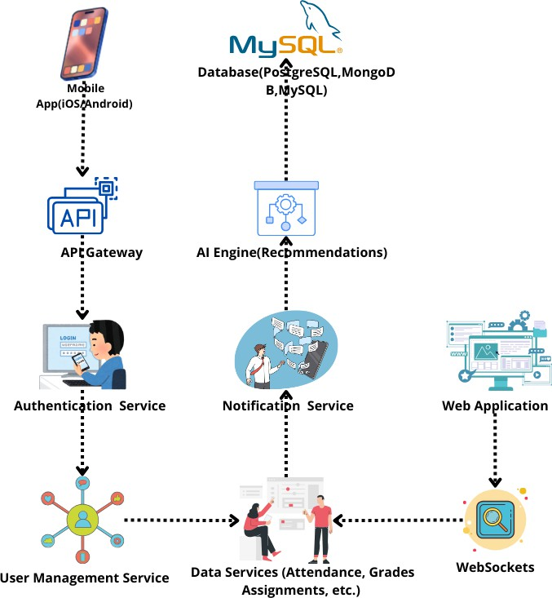

Figure 4.1: How Linking Mobile App, Web Application and various backend services

The figure 4.1 shows how the mobile application, web application, and various backend services are integrated together. As shown above, this integration forms the backbone of our compre- hensive educational platform. In the following, we illustrate how these components interact and work together seamlessly.

* + 1. **Client Side (Mobile Application)**

The mobile application is developed for both iOS and Android platforms. This cross-platform approach serves as a primary interface for students and parents, providing a consistent experi- ence across different mobile devices. The mobile application components are:

* **User Interface:** The mobile application offers a user-friendly interface with various screens and functionalities, including screens for login, dashboard, attendance, grades, notifications, AI recommendations, etc.
* **Network Manager:** Responsible for managing API calls to the backend services.
* **Local Storage:** Used for caching data and providing offline access.
* **Notification Service:** Enables receiving real-time updates and push notifications.
  + 1. **Client Side (Web Application)**

The client-side web application is designed to be accessible through standard web browsers, ensuring a platform-agnostic experience for users. It allows teachers, administrators, and academies to access the system from any device with a compatible web browser. As designed in the third chapter, the web application includes:

* **User Interface:** Offers tailored interfaces for teachers, administrators, and academies, catering to the specific needs and workflows of each user group.
* **Admin Tools:** Includes tools to manage students, courses, attendance, grades, and announcements.
* **Analytics Dashboard:** Provides metrics such as attendance rates, grade distributions, and other key performance indicators.
  + 1. **Backend Services**

The backend is the set of technology responsible for processing incoming requests, generating the appropriate response, and sending it back to the client. It typically consists of three main components: the server, the application, and the database [11]. Our backend services include:

* **API Gateway:** Acts as a centralized entry point for all API requests from the client-side applications (web, mobile, etc.).
* **Authentication Service:** Handles user login, registration, and authentication.
* **User Management Service:** Manages user profiles, roles, and permissions.
* **Data Services:** Handles CRUD operations (Create, Read, Update, and Delete) related to attendance, grades, assignments, etc.
* **Notification Service:** Responsible for sending real-time notifications and updates to the mobile app and web application.
* **AI Engine:** Provides personalized lesson and exam recommendations.
  + 1. **Database**

Databases provide a structured way to organize and store the data required by the web appli- cation. Databases offer an interface to store data permanently in memory [12]. To organize and store the data, we have utilized a MySQL relational database management system (RDBMS) which acts as the connection between the database and the end-users of the web application. The database components are:

* **User Data:** Stores information about students, parents, teachers, and administrators.
* **Academic Data:** Stores academic-related information, such as attendance records, grades, assignments, and other academic information.
* **Notification Data:** Stores details of notifications and updates sent to users.
* **AI Recommendations Data:** Stores all data related to the personalized learning rec- ommendations provided by the AI Engine.
  + 1. **Communication and Integration**

To communicate and exchange data between the mobile application, web application, and backend services, we have used the following combination of communication and integration technologies:

* **APIs:** RESTful APIs are used for communication between the mobile app, web applica- tion, and backend services.
* **Web Sockets:** Used for real-time communication and instant updates.
* **Push Notifications:** Services like Firebase Cloud Messaging (FCM) are used for sending push notifications to mobile devices.
* **Data Synchronization:** Ensures data consistency between the mobile app, web appli- cation, and backend services.
  + 1. **Security**

To address robust security measures, we have used the following security aspects:

* **Encryption:** To maintain data confidentiality, all data transmitted between the mobile app, web application, and backend services is encrypted using HTTPS.
* **Authentication and Authorization:** Uses OAuth 2.0 for secure authentication and authorization.
* **Data Privacy:** Ensures compliance with data protection regulations.

**An overview of Adross Mobile Application**

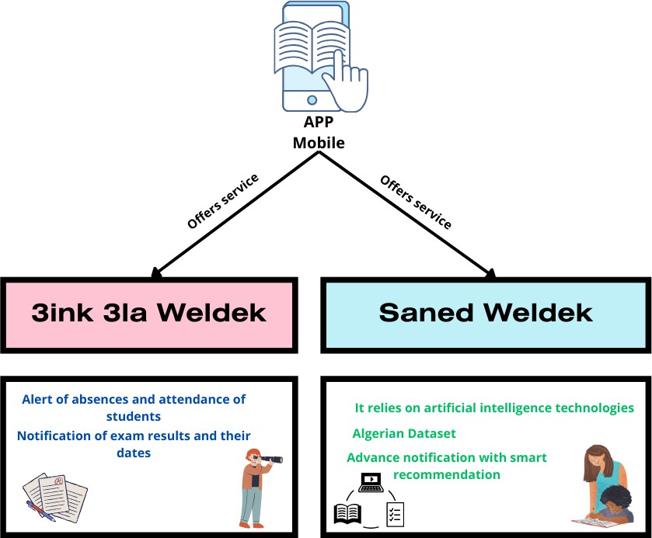

Figure 4.2: Overview of Adross Mobile Application

The figure 4.2 shows an overview of our Adross mobile application with its two components: "3inak 3la Weldek" and "Sanad Weldek".

* + 1. **Adross Mobile Application Components**

**"3inak 3la Weldek"** tool provides alerts and notifications to parents about their child’s ab- sences and attendance at school. In addition, it notifies parents about their child’s exam results and the dates of upcoming exams and tests.

**"Sanad Weldek"** tool relies on artificial intelligence technologies and offers smart and person- alized recommendations providing necessary support to parents and their children aligning with timetable and exam scheduling. Moreover, Sanad Weldek provides timely notifications and ac- cess to relevant educational resources (courses, tests, and exams) using web scraping techniques to create a comprehensive dataset specific to the Algerian educational curriculum.

In the rest of this chapter, we will detail the flowchart diagrams of “3inak 3la Weldek" and "Sanad Weldek" tools.

* 1. **3inek 3la Weldek**
     1. **Its Purpose and Features**

To address the gap in the Algerian educational system, "3inek 3la Weldek" is designed to keep parents informed and engaged in their child’s academic progress by providing real-time alerts and notifications. It has two main features which are:

**Alert of Absences and Attendance**

* Real-time notifications for each instance of absence.
* Summary reports of attendance over specific periods (daily, weekly, monthly).

**Notification of Exam Results and Dates**

* Notifications about upcoming exams and their schedules.
* Instant alerts when exam results are published.
* Detailed performance reports.
  + 1. **Flowchart for "3inek 3la Weldek"**

The flowchart diagram shown in Figure 4.3 depicts the process flow of the "3inek 3la Weldek" tool and outlines the various steps involved in tracking student attendance, sending notifications to parents, and handling exam results. The order of these steps is:

1. **Start:** The process initiates when the student scans their ID card upon entering and leaving school, or when the teacher marks attendance in the school’s system.
2. **Attendance Data Updated:** The attendance data is updated within the school’s sys- tem, either through manual entry by teachers or automated systems like ID card scanners.
3. **Backend Server Retrieves Attendance Data:** The backend server, connected to the school’s system, retrieves the updated attendance data in real-time to ensure immediate processing.
4. **Check for Absence:** The system checks if the student is marked absent by comparing the current attendance data against the student’s expected schedule.
5. **Send Absence Alert (if absent):** If the student is absent, an alert is generated and sent to the parent’s mobile app via a push notification. For example: "Your child, [Student Name], is absent today."
6. **Parent Receives Notification:** The parent receives the absence alert on their mobile device, enabling them to take any necessary actions promptly.
7. **Teacher Enters Exam Results:** When exams are conducted, the teacher enters the exam results into the school’s system. This ensures that all academic performance data is accurately recorded.
8. **Backend Server Retrieves Exam Results Data:** The backend server retrieves the newly entered exam results from the school’s system, ensuring the data is updated in real-time.
9. **Send Exam Results Notification:** A notification about the exam results is sent to the parent’s mobile app. For example: "Your child, [Student Name], has received [Grade] in [Subject]."
10. **Parent Receives Notification:** The parent receives the exam results notification on their mobile device, keeping them well-informed about their child’s academic performance and enabling them to provide timely support.
11. **End:** The process concludes once the parent has received the notification about the exam results, ensuring they are continuously updated on their child’s school activities.

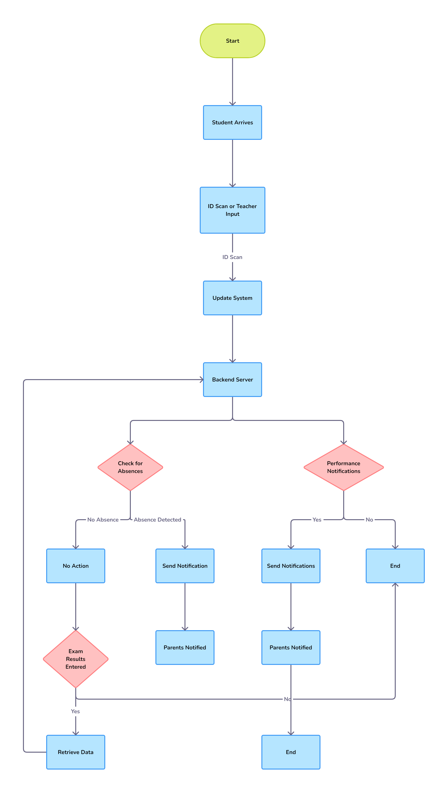

Figure 4.3: Flowchart of "3inek 3la Weldek"

* + 1. **Strengths of "3inek 3la Weldek" tool**

To summarize, our tool "3inek 3la Weldek" has various strengths that result in an enhanced user experience, personalized dashboard, advanced notifications, and robust data security measures. Each strong point is addressed as follows:

* **Enhanced User Experience:** Our tool provides a user-friendly interface, making it easy for parents to navigate and access important information.
* **Personalized Dashboard:** Offers a customized dashboard tailored to individual stu- dents, providing parents with a comprehensive view of their child’s academic performance and attendance.
* **Advanced Notifications:** Provides real-time notifications and alerts, ensuring that parents receive immediate updates about their child’s attendance and exam results.
* **Data Security:** Implements robust security measures to protect sensitive information, ensuring data privacy and compliance with international standards.
* **Localized Content:** Tailored to the Algerian education system, ensuring relevance and alignment with the local curriculum and educational practices.
  1. **Saned Weldek**

After having detailed the design of the first component of the mobile part, which is the "3inek 3la Weldek" tool, we will now explore and detail the design of its second component called “Saned Weldek”.

**Its Purpose and Features**

As mentioned in Figure 4.5, the “Saned Weldek” tool is an AI-powered service aiming to enhance the educational experience for Algerian students and parents by delivering personalized support tailored to the local educational context. Specifically, this intelligent tool provides:

* **Personalized Recommendations:** Provides recommendations for content and activi- ties in line with the Algerian school curriculum.
* **Schedule and Exam Planning:** Takes into account the student’s schedule as well as the planning of exams and tests.
* **Data Integration:** Integrates AI-driven algorithms and web scraping techniques to gather and analyze data from various famous Algerian educational platforms (DZ Exam and Ency-Education) to create a comprehensive dataset tailored to the Algerian educa- tional context.
  + 1. **Recommendation Process in Saned Weldek**

To provide a comprehensive understanding of the features and functionalities employed in the “Saned Weldek” tool, the next two subsections will detail the recommendation algorithms and data collection processes.

**Algorithm Used**

The recommendation technique used in “Saned Weldek” is Content-Based Filtering using Term Frequency-Inverse Document Frequency (TF-IDF) and Cosine Distance Similarity.

* **Content-Based Filtering Technique:**
  + Saned Weldek utilizes a content-based filtering technique to recommend educational resources (items) based on their features and the student’s preferences and needs.
  + The system recommends topics that are similar to the ones the student has already shown interest in or interacted with.
  + It computes the similarity among pairs of items using TF-IDF and cosine distance based on their descriptions and then recommends items with the highest similarity scores.
* **TF-IDF (Term Frequency-Inverse Document Frequency):**
  + TF-IDF is a numerical statistic that reflects the importance of a term in a document relative to a collection of documents.

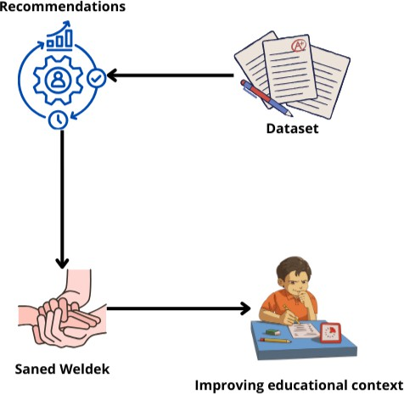

Figure 4.4: Saned Weldek Purpose

* + In ‘Saned Weldek’, TF-IDF is used to convert the text descriptions of educational topics into numerical vectors, where each term’s importance is weighted by its fre- quency in the document and inversely proportional to its frequency in the entire corpus.
* **Cosine Similarity:**
  + Cosine similarity is a measure used to calculate the similarity between two vectors in a multi-dimensional space. The cosine similarity score ranges from -1 to 1, where 1 indicates perfect similarity and -1 indicates complete dissimilarity between the two vectors.
  + In Saned Weldek’s recommendation process, cosine similarity is used to determine the similarity between the TF-IDF vectors representing the educational resources.
  + By calculating the cosine similarity between the user’s preferred topics (represented as TF-IDF vectors) and the available educational content, the system can identify and recommend the most relevant and similar topics to the user.

**Data Collection via Web Scraping:**

In order to create our dataset of educational resources and content tailored to the Algerian educational context, "Saned Weldek" applies web scraping techniques to target well-known and widely used Algerian educational platforms, such as DZ Exam and Ency-Education. The

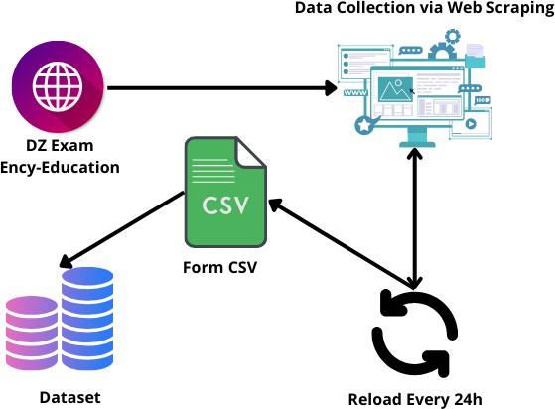

Figure 4.5: Saned Weldek Purpose

system employs web scraping techniques to extract relevant educational data from prominent Algerian educational websites such as *DZ Exam* and *Ency-Education*.

* **DZ Exam**: This site provides past exam papers, solutions, and various educational resources, crucial for understanding exam patterns and frequently asked questions.
* **Ency-Education**: This site offers comprehensive educational content, including subject- wise study materials, guides, and tutorials.

The diagram illustrates the process of data collection from the websites *DZ Exam* and *Ency- Education* via web scraping, forming a CSV file that is updated every 24 hours, and subsequently feeding this data into a dataset for further use. Here’s a detailed breakdown of each step, potential issues, and solutions.

* + 1. **Process Breakdown**
       1. **Data Collection via Web Scraping Source Websites:**
          - **DZ Exam**: This site likely contains exam-related data, past papers, results, and educa- tional materials.
          - **Ency-Education**: This site probably offers encyclopedic educational content, tutorials, and guides.
       2. **Form CSV**

The scraped data is structured and saved into a CSV file format. This step involves parsing the collected HTML data, extracting relevant information, and organizing it into a tabular format.

* + - 1. **Reload Every 24h**

The scraping process is automated to run every 24 hours to ensure the dataset remains up-to- date with the latest information from the source websites.

* + - 1. **Dataset**

The CSV file is imported into a dataset, which can be used for analysis, reporting, or integration into other applications.

**Detailed Reports**

**Data Collection Report Web Scraping Techniques:**

* + - * + **Tools Used**: Python libraries like BeautifulSoup, Scrapy, or Selenium.
        + **Methods**: Automated scripts that send HTTP requests to the websites, parse the HTML content, and extract the required information.
        + **Data Points**: Exam dates, subject information, question papers, results, tutorials, guides.

**Challenges:**

* + - * + **Dynamic Content**: Handling JavaScript-loaded content which requires tools like Sele- nium.
        + **Anti-scraping Measures**: Dealing with CAPTCHA, IP blocking, and rate limiting by using proxies, rotating IP addresses, and respecting robots.txt.

**CSV Formation Report Data Cleaning:**

* + - * + Removing unnecessary HTML tags, handling missing values, and standardizing formats (dates, numbers).
        + Ensuring consistency in data fields across different time periods.

**Data Structuring:**

* + - * + Organizing data into rows and columns with headers like “Exam Date”, “Subject”, “Paper Type”, “Result”, “Content Type”.
        + Ensuring each record is unique and timestamped for tracking updates.

**24-Hour Reload Automation Report Automation Tool:**

* Using cron jobs (Linux) or Task Scheduler (Windows) to schedule the scraping script every 24 hours.
* Ensuring the script runs at a time when the source websites are least likely to be updated to avoid partial data collection.

**Data Validation:**

* Implementing checks to compare the newly scraped data with existing data to identify changes or additions.
* Logging errors and discrepancies for review.

**Problem Report and Solutions**

**Problem: Dynamic Content Loading**

* **Solution**: Utilize Selenium to automate browser interactions and capture fully rendered HTML content.

**Problem: Anti-scraping Mechanisms**

* **Solution**: Implement IP rotation, use proxies, and respect the website’s robots.txt file to avoid being blocked. Use services like ScraperAPI or ProxyMesh.

**Problem: Data Inconsistency**

* **Solution**: Establish a data validation pipeline that checks for consistency in formats and missing values. Use Pandas in Python to handle data cleaning.

**Problem: High Traffic or Downtime**

* **Solution**: Schedule scraping during off-peak hours. Implement error handling to retry scraping in case of failures.

**Problem: Large Data Volume**

* **Solution**: Implement pagination handling in the scraper and optimize data storage meth- ods. Use cloud storage solutions if necessary.

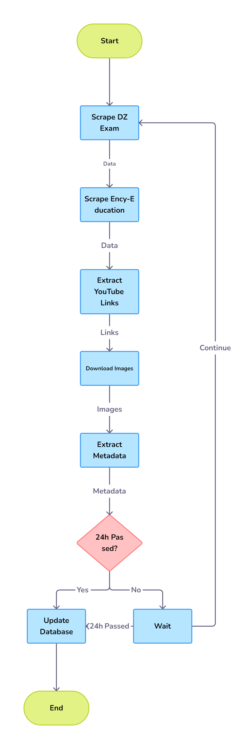

Figure 4.6: Flow Chart Of Web Scraping

By following the outlined process, ensuring robust error handling, and addressing common scraping issues, you can maintain a reliable and up-to-date dataset from *DZ Exam* and *Ency- Education* websites. Regularly reviewing the scraping scripts and data quality will help in achieving accurate and useful data collection.

**Creating the Algerian Dataset**

**Data Aggregation**

* The data scraped from these websites includes exam papers, solutions, study guides, and other educational materials.
* Additional data is collected from user interactions within the "Saned Weldek" app, such as study habits, topic preferences, and performance metrics.

**Data Cleaning and Processing**

* The raw data is cleaned to remove any inconsistencies, duplicates, and irrelevant infor- mation.
* The cleaned data is then processed and structured into a usable format for training the machine learning models.

**Dataset Characteristics**

* The dataset is specifically curated to reflect the Algerian education system, incorporating local curriculum standards, commonly used educational resources, and linguistic nuances.
  + 1. **From Content-Based to Filtering and Behavior Analysis**

**Collaborative Filtering**

* This technique is used to recommend educational content based on similarities between users’ study habits and preferences.
* The algorithm identifies patterns in how students interact with study materials and exams, suggesting resources that have helped similar students succeed.

**Behavior Analysis**

* The system continuously monitors and analyses user behavior, including study times, content engagement, and performance trends.
* Based on this analysis, the algorithm dynamically adjusts recommendations to suit the evolving needs and habits of each student.

**Personalized Notifications**

* Using the insights gained from behavior analysis, the app sends personalized notifications to students and parents.
* These notifications may include reminders about upcoming exams, suggestions for addi- tional study materials, and alerts about areas that need more focus.
  + 1. **Implementation and User Experience**

**User Interface and Interaction**

* The "Saned Weldek" app features an intuitive interface where students and parents can access personalized study plans, recommended lessons, and exam preparation tips.
* Users receive notifications and recommendations in real-time, ensuring they are always up-to-date with their academic progress.

**Feedback Loop**

* The system incorporates a feedback loop where users can rate the usefulness of the rec- ommendations and content.
* This feedback is used to further refine the algorithms, improving the accuracy and rele- vance of future recommendations.

**Integration with Schools**

* Saned Weldek integrates with school management systems to access academic records and performance data.
* This integration helps in tailoring recommendations to align with the student’s school curriculum and performance history.
  + 1. **Advantages of Saned Weldek**

**Localized Content**

* By focusing on Algerian educational resources and standards, Saned Weldek ensures that the recommendations are highly relevant to the local context.

**Real-Time Adaptation**

* The use of AI allows the system to adapt in real-time to changes in a student’s learning behavior and needs.

**Comprehensive Support**

* The app not only provides study materials and recommendations but also helps in tracking academic progress, offering a holistic approach to student support.

**Parental Involvement**

* Parents can stay informed about their child’s academic activities and progress, enabling them to provide timely support and encouragement.
  1. **Conclusion**

Throughout this chapter, we have explained the design of the mobile part with its two com- ponents *3inak 3la Weldek* and *Sanad Weldek*. In the final chapter, we will move on to the implementation phase of the *Moassasti*, *A3rad darssek*, and *Adross* systems.

Chapter 5

Implementation And Development

* 1. **Introduction**

After completing the design process of our comprehensive framework *Darris Bi Dhakaa*, which has two parts covered in the previous two chapters, in this fifth chapter, we move on to the implementation phase of the *Moassasti*, *A3rad darssek*, and *Adross* systems.

For each one, we describe the set of infrastructures and technologies used for their realization and their deployment. Moreover, we discuss the advantages of these technological choices and how they align with the project requirements. Finally, we provide an overview of each system (*Moassasti*, *A3rad darssek*, and *Adross*) in the form of screenshots describing and explaining how these interfaces are integrated with the different access modes.

* 1. **“Darris Bi Dhakaa” Backend Implementation**

In the next sections, we will focus on detailing the implementation of the *Darris Bi Dhakaa* framework, which is composed of two parts: a web part and a mobile part, as mentioned in Figure 5.1. More precisely, in the first part, we will focus on its two important web application tools: *Moassasti* and the *A3rad darssek* Meeting Platform.

61

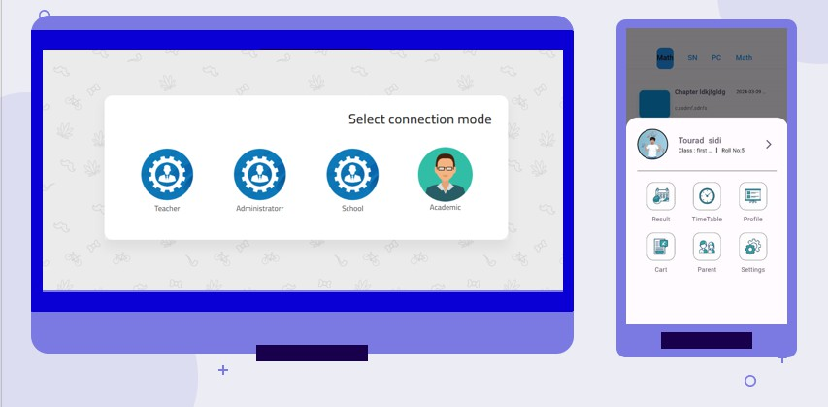

Figure 5.1: Darris Bi Dhakaa Platform

* + 1. **“Moassassati” Backend Implementation**
       1. **Infrastructures & Technologies**

The Moassassati backend solution was implemented as a dynamic Web application. Its imple- mentation involves various technologies and programming languages including:

**Laravel (PHP Framework)**

Laravel is used for backend development due to its elegant syntax, MVC architecture, and powerful features [13].

To build a robust web application, we have chosen Laravel, a PHP framework, for the backend development of *Moassassati* due to its elegant syntax, solid MVC (Model-View-Controller) architecture, which helps in separating concerns, improving code organization, and promoting reusability.

To provide a rich backend solution for the *Moassassati* system, both Laravel Passport and the Laravel Permission packages are used. By using these two Laravel packages, the *Moassassati* backend application can benefit from:

* + - * + **Secure and standardized API authentication using OAuth2:** Laravel Passport provides a full OAuth2 server implementation for your Laravel application in a matter of minutes, allowing you to authenticate API requests using a simple yet secure token-based system.
        + **Efficient management of user permissions and access control:** Laravel Permission allows you to manage user roles and permissions in a database-driven approach, enabling fine-grained control over user access to various parts of the application.
        + **Improved maintainability of the codebase:** The use of these packages ensures that the code remains clean, organized, and easy to maintain, which is crucial for the long-term success of the application.

**MySQL**

Databases are used for organizing and storing data permanently. For storing and managing the data of the *Moassassati* system,

MySQL, a relational database management system (RDBMS), is used [14].

As has already been explained in the previous chapters, *Moassassati* is not just a simple edu- cation platform, but a fully-fledged system handling various aspects of the educational process. The best proof is what is depicted in Figures 5.2 and 5.3. The database schema diagrams depicted in these figures clearly demonstrate the breadth of functionality, stakeholder manage- ment, and security features.

To give an overview of this database schema based on the classification and examples men- tioned:

**User and Role Management Tables**

* + - * + The **education_users** table: contains the basic user information (students, parents, teachers, etc.).
        + The **education_role_has_permissions** table: defines the permissions associated with each role.
        + The **education_model_has_permissions** table: associates the data models with their corresponding permissions.

**Tracking Educational Activities Tables**

* + - * + The **education_tests** table: records information about tests.
        + The **education_messages** table: preserves the history of conversations and exchanges between the different stakeholders.
        + The **education_exams** table: stores details about exams, including the enrolled stu- dents and their scores.

**Educational Content Management Tables**

* + - * + The **education_classes** table: contains information about classes.
        + The **education_sections** table: allows for the structuring of classes into distinct sec- tions.
        + The **education_lessons** table: references the lessons, with their description and the responsible teacher.

**Scheduling and Timetabling Tables**

* + - * + The **education_timetables** table: stores the timetables, with the associated sessions, subjects, and classrooms.
        + The **education_sections** table: is linked to **education_timetables** to connect the sections with the corresponding schedule slots.

Our database is called “education” and is made up of 58 tables. The full description of principal tables is detailed in Appendix (A).

**Laravel Passport**

Laravel Passport is an API authentication package. [15]

* + - * + OAuth2 Implementation: Ensures secure API authentication.
        + User Token Management: Simplifies issuing and managing API tokens.

**Laravel Permission Package**

The Laravel Permission Package is used for managing user roles and permissions.

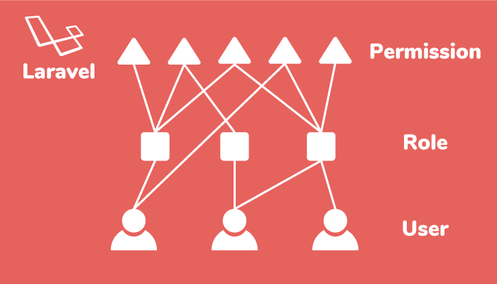

* + - * + Role-Based Access Control: Facilitates granular control over user permissions.
        + Easy Integration: Seamlessly integrates with Laravel’s authentication system.

Figure 5.2: Data base MySQL part 1

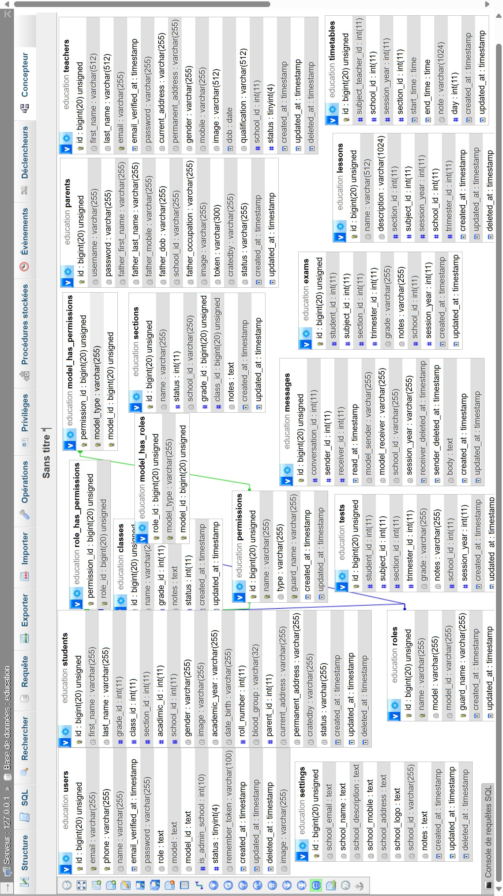

Figure 5.3: Data base MySQL part 2

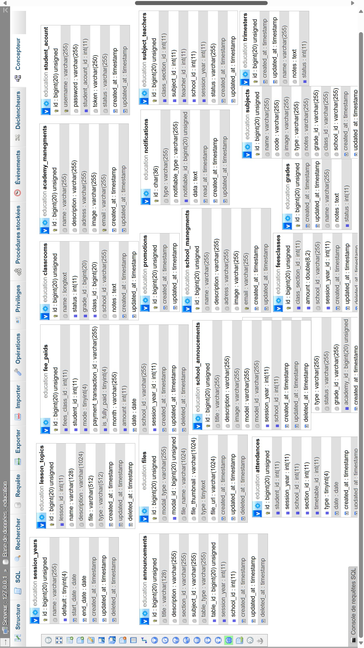

* + - 1. **Usage scenarios in “Moassassati”**

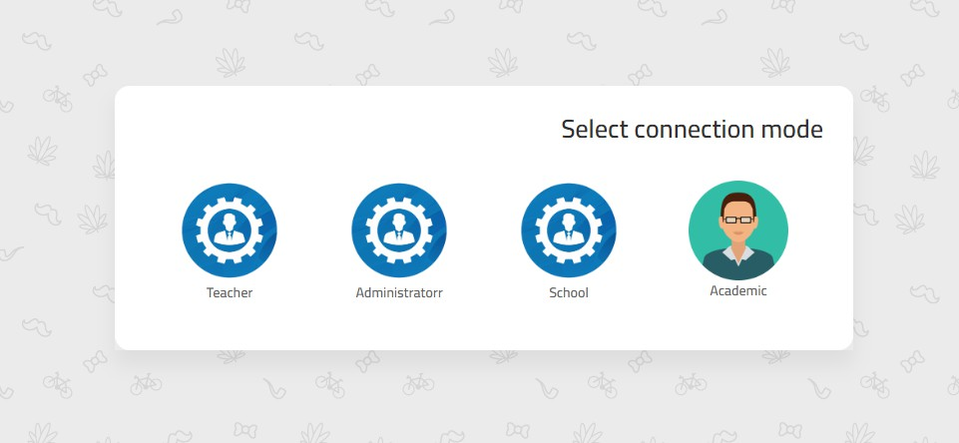

Figure 5.4: Moassassati platform

As shown in Figure 5.4, the "Select Connection Mode" screen is the home page of the *Moassas- sati* platform, enabling different actors to select their appropriate role and access the platform’s services catered to their specific needs as teachers, administrators, schools, or academics. The roles and their corresponding functionalities are described as follows:

* + - * + **Academic:** This mode is meant for users involved in academic planning and oversight, such as curriculum designers, academic advisors, or education inspectors. It might offer tools for curriculum management, academic performance analysis, and policy implemen- tation.
        + **School:** This mode is intended for school-level access, possibly for roles such as principals or other school officials who oversee the entire school’s functioning. It would include high- level administrative features and reports.
        + **Administrator:** This mode is for school administrators who need to access administra- tive tools. It provides functionalities for managing school operations, including student enrollment, teacher assignments, and overall school management.
        + **Teacher:** This mode allows teachers to manage class schedules, take attendance, grade students, and communicate with students and parents.

In the following sections, we will present various screenshots showing the different functionalities of the *Moassassati* platform, focusing on Administrator and Teacher modes.

**Administrator Mode**

After choosing the Administrator mode, the login screen presented in Figure 5.5 allows only authorized administrators to perform their administrative tasks within the system.

The screen requires the administrator to enter their username, serving as the unique identifier for their account.

In addition to the username, the administrator must also enter a password to authenticate their identity and gain access to the platform.

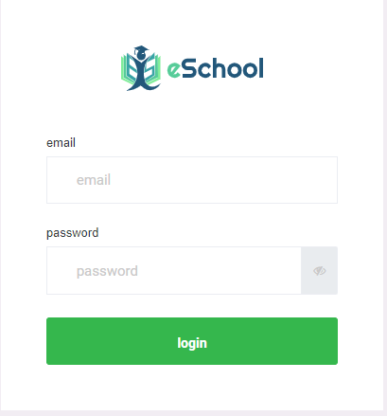

Figure 5.5: Interface of the login page for administrator

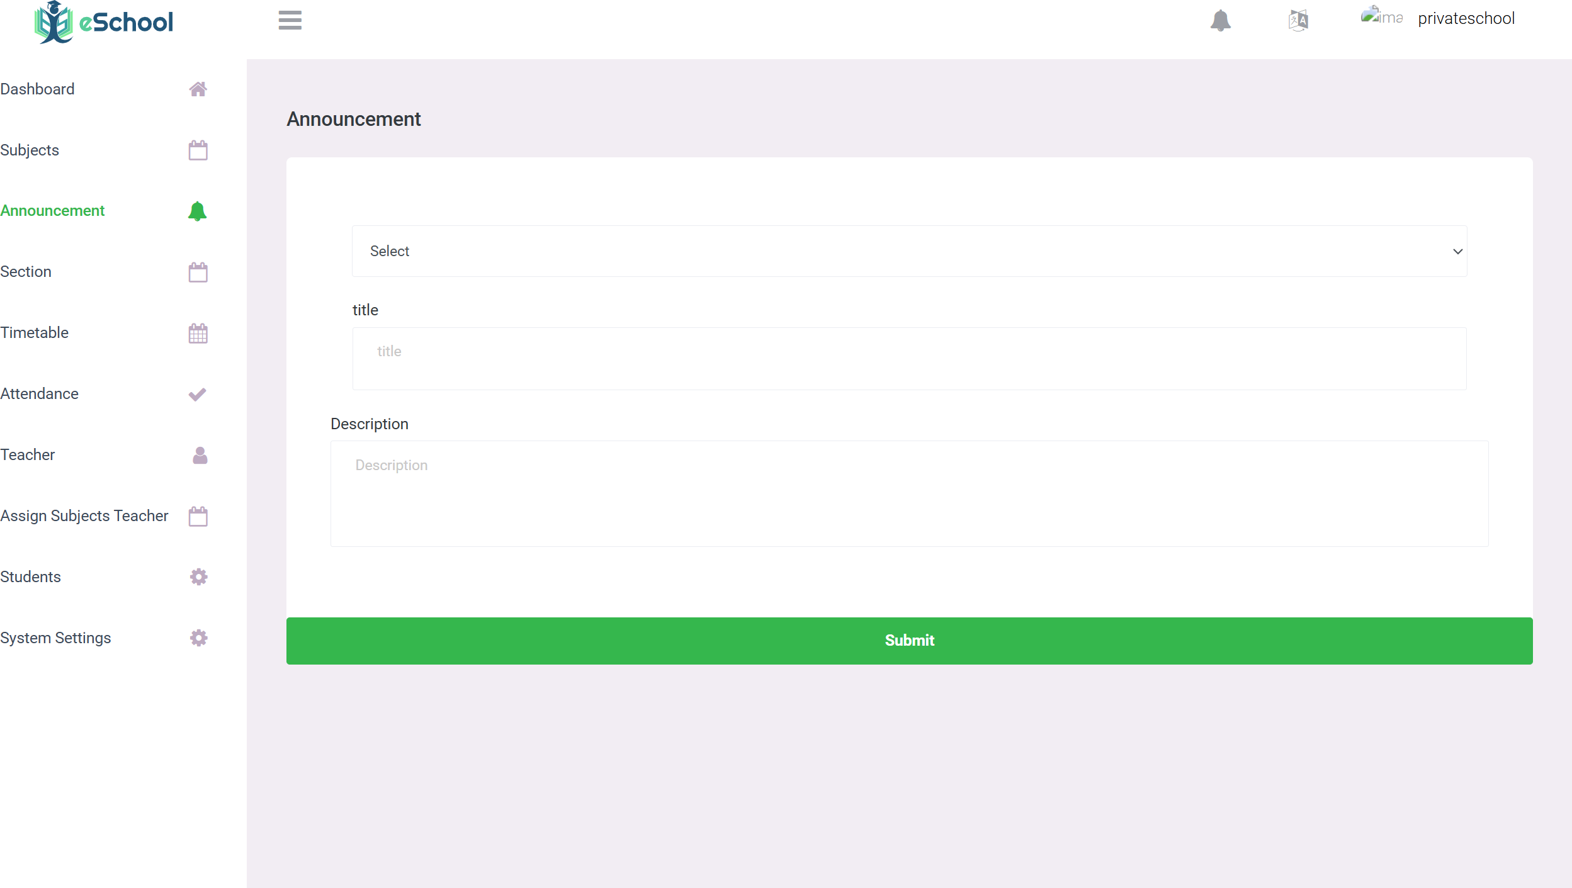

Figure 5.6: Announcement

As shown in Figure 5.6,this interface enables the administrator to send notifications or alerts to teachers,or students, workers in the sector, parents of students quickly and instantly As shown

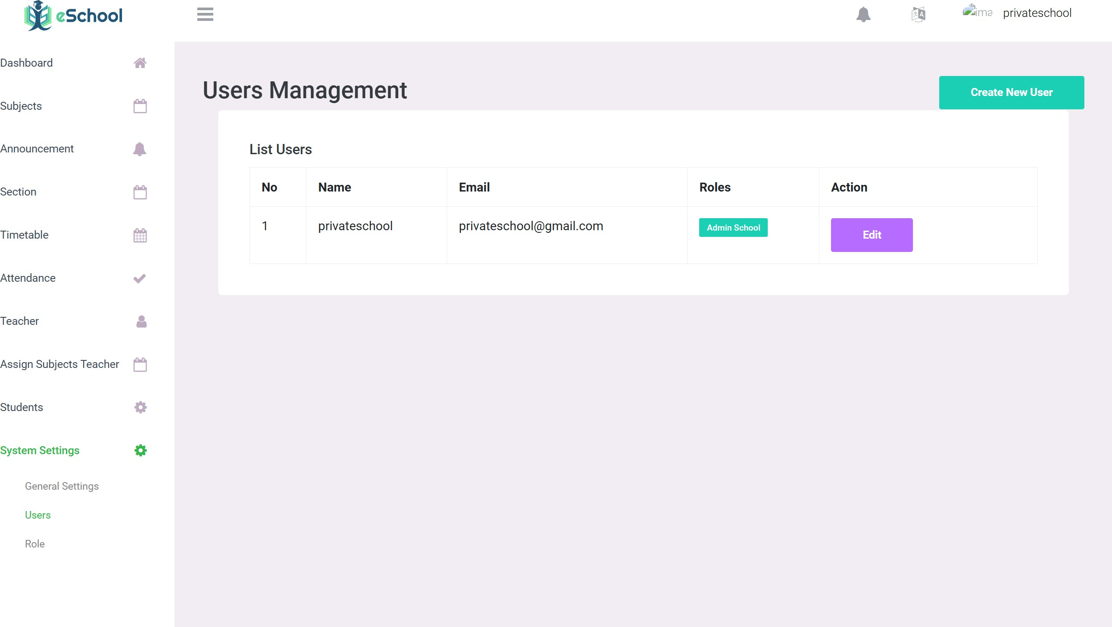

Figure 5.7: Users role

in Figure 5.7,this interface enables the administrator to View all users of the system and all users who have been given permissions by the administrator

**School Mode**

* **School Mode:** Enables access to tools tailored for classroom management and student engagement, allowing teachers to efficiently handle their daily tasks.

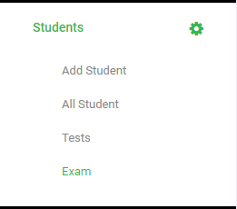

Figure 5.8: Students section

As shown in Figure 5.8,this is a section dedicated to creating and students,The school administration can create accounts for students and create databases for them he can also attach each student to his own class or section

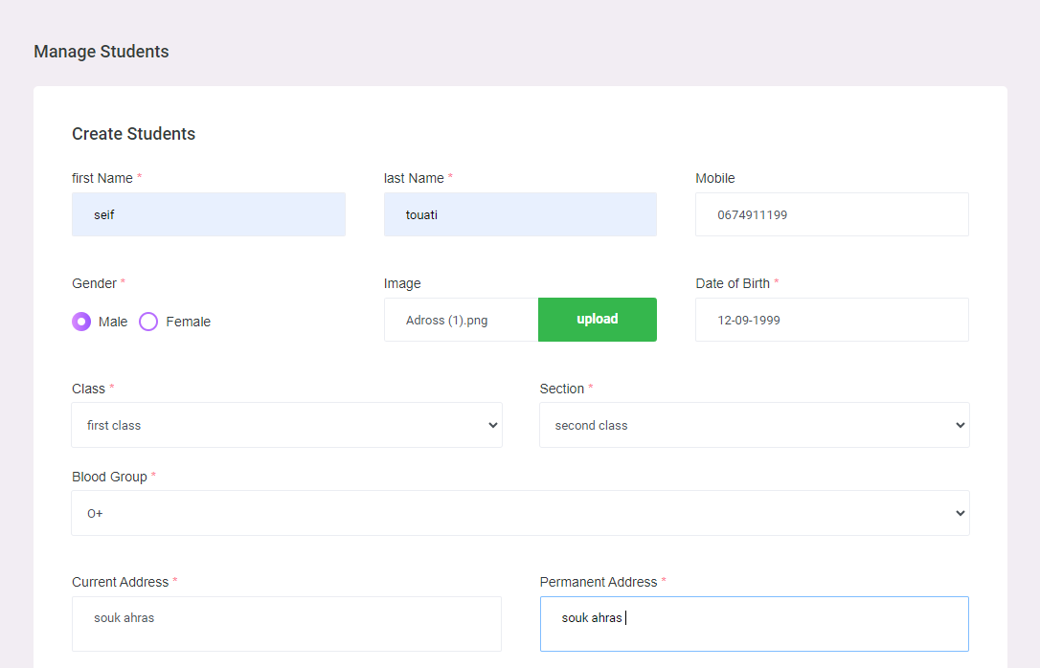

Figure 5.9: Add new student

As shown in Figure 5.9,the person in charge of renewing the students includes all the information related to the student’s college on the phone number belt and the information about him and his guardians.

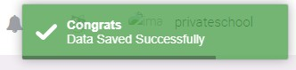

Figure 5.10: Data saved

in Figure 5.10,after completing all this information, a warning will come here ,Where the content tends to be that the student’s information has been saved in the database

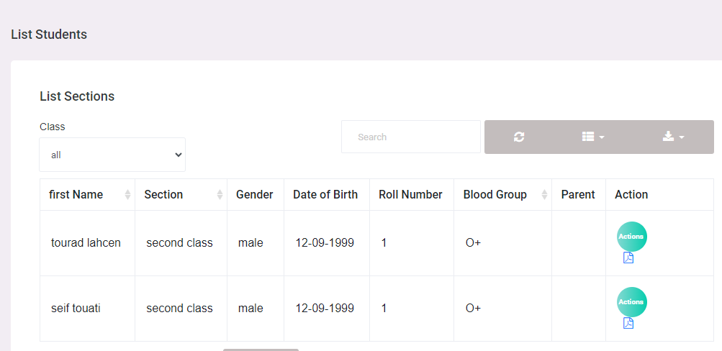

Figure 5.11: list of Students

in Figure 5.11,here we can see all the registered students, and the administrator can edit and delete them and view all their information

**Teacher Mode**

* **Teacher Mode:** Offers a broader view and control for managing overall school activities, focusing on higher-level decision-making and resource allocation.

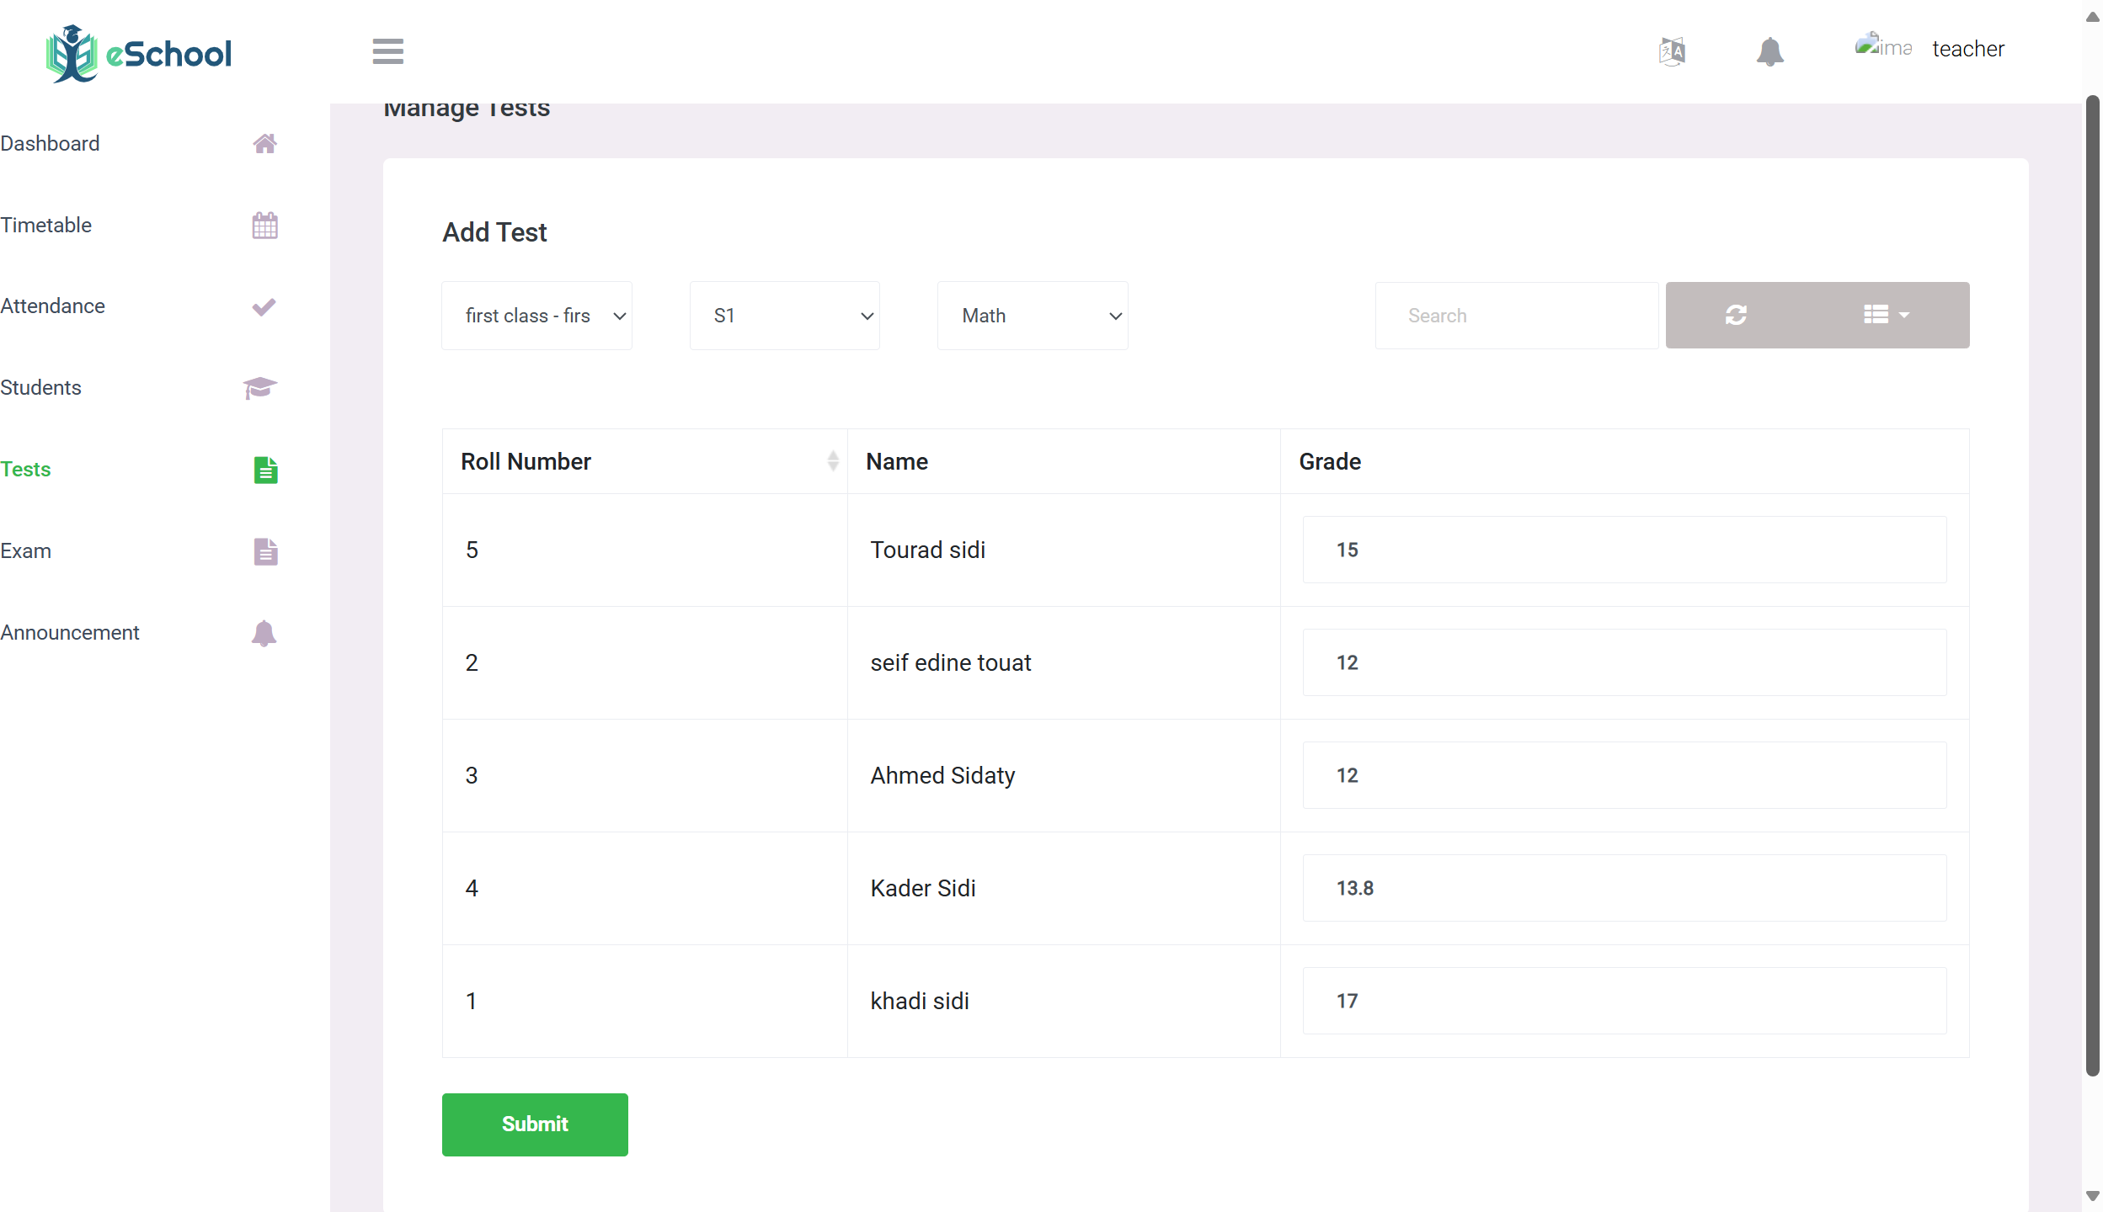

Figure 5.12: Establish Test points

As shown in Figure 5.12,an interface that enables the teacher to easily set test marks for each section, because we neglected the process of setting the sections he studies.

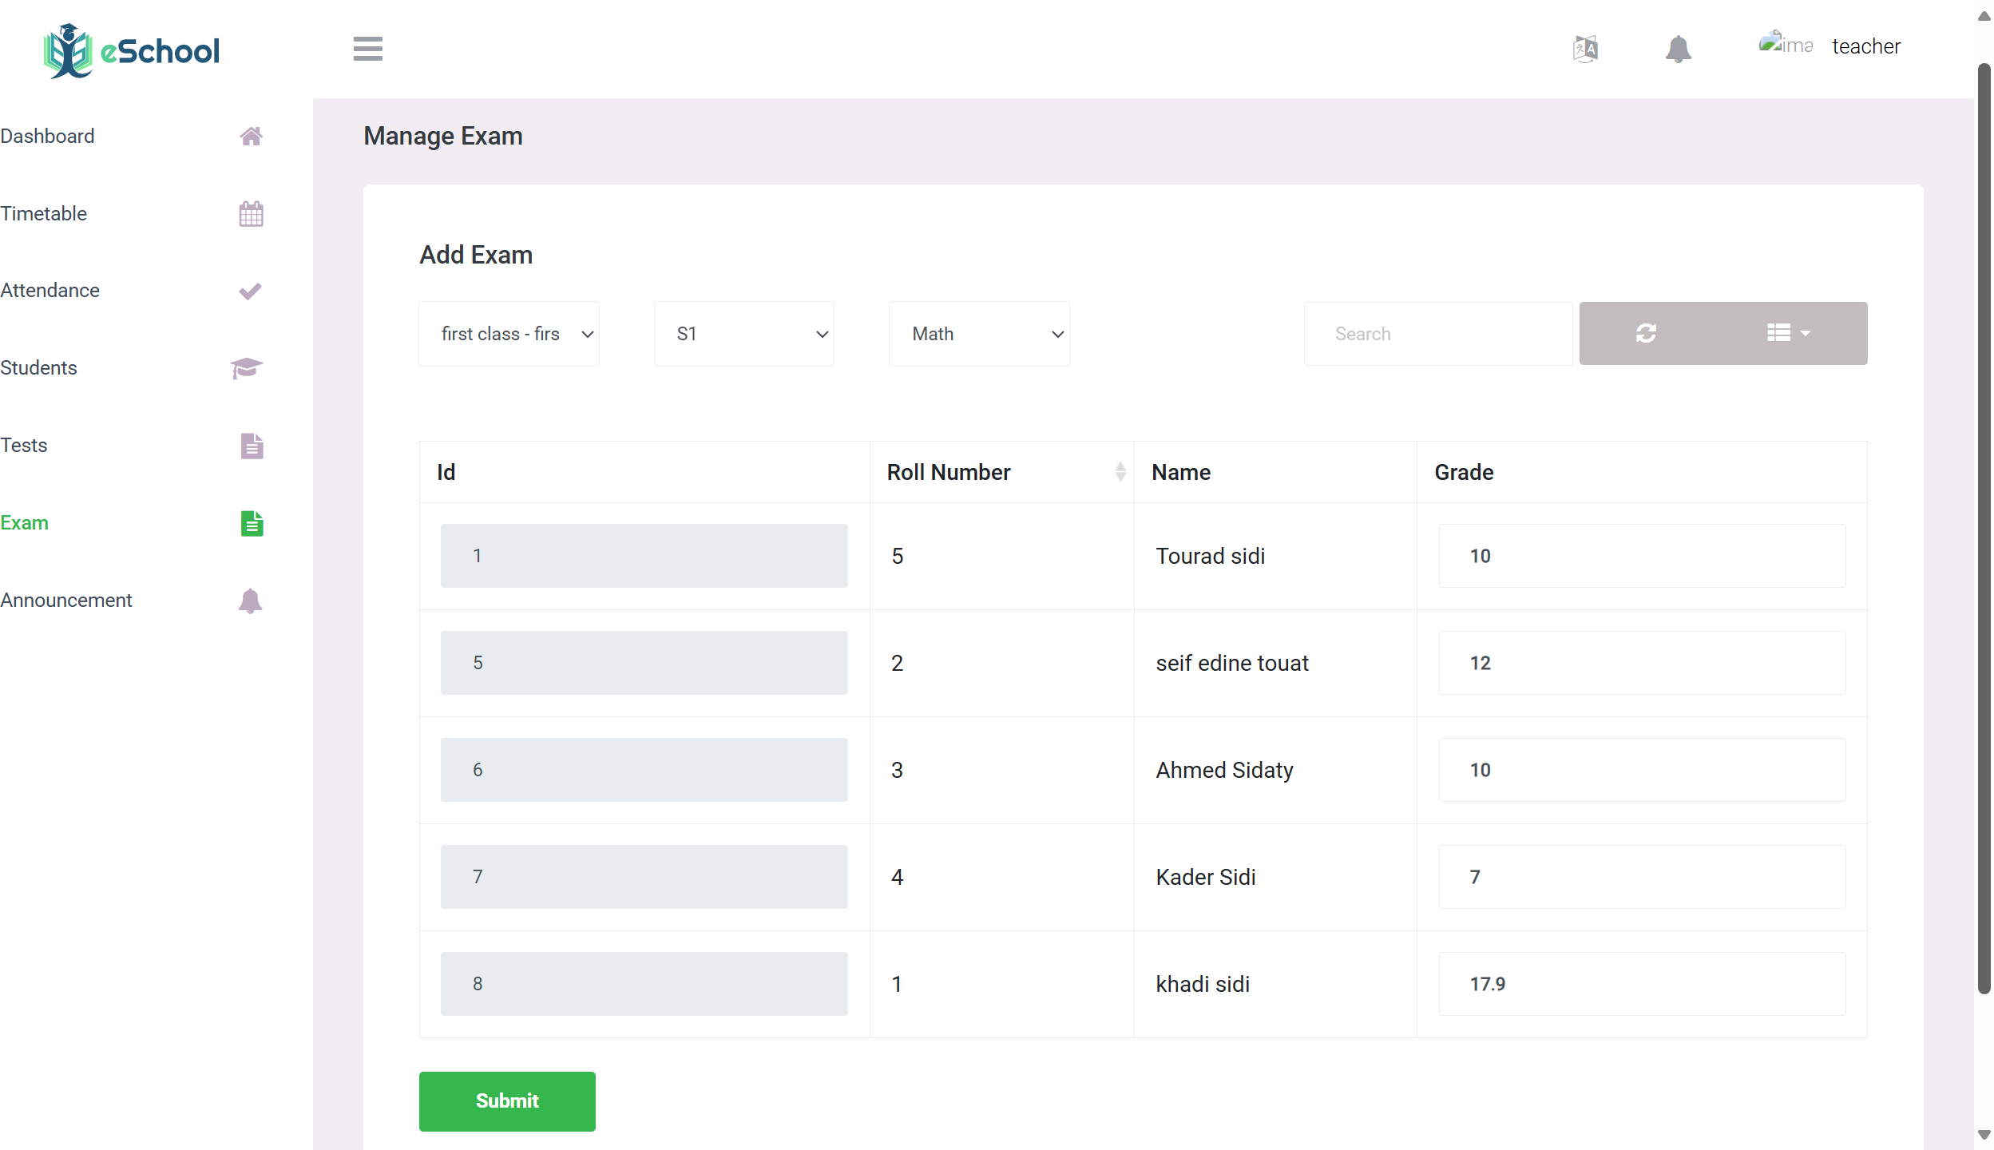

Figure 5.13: Establish exam points

As shown in Figure 5.13,an interface that enables the teacher to easily set Exam notes marks for each section, because we neglected the process of setting the sections he stud- ies,these grades are sent to the administration and to the student’s guardian and student after verification

* **Academic Mode:** Focuses on academic oversight, providing insights into curriculum management, educational standards, and academic performance to ensure educational quality and compliance with standards.

Figure 5.14: platform -dash borad

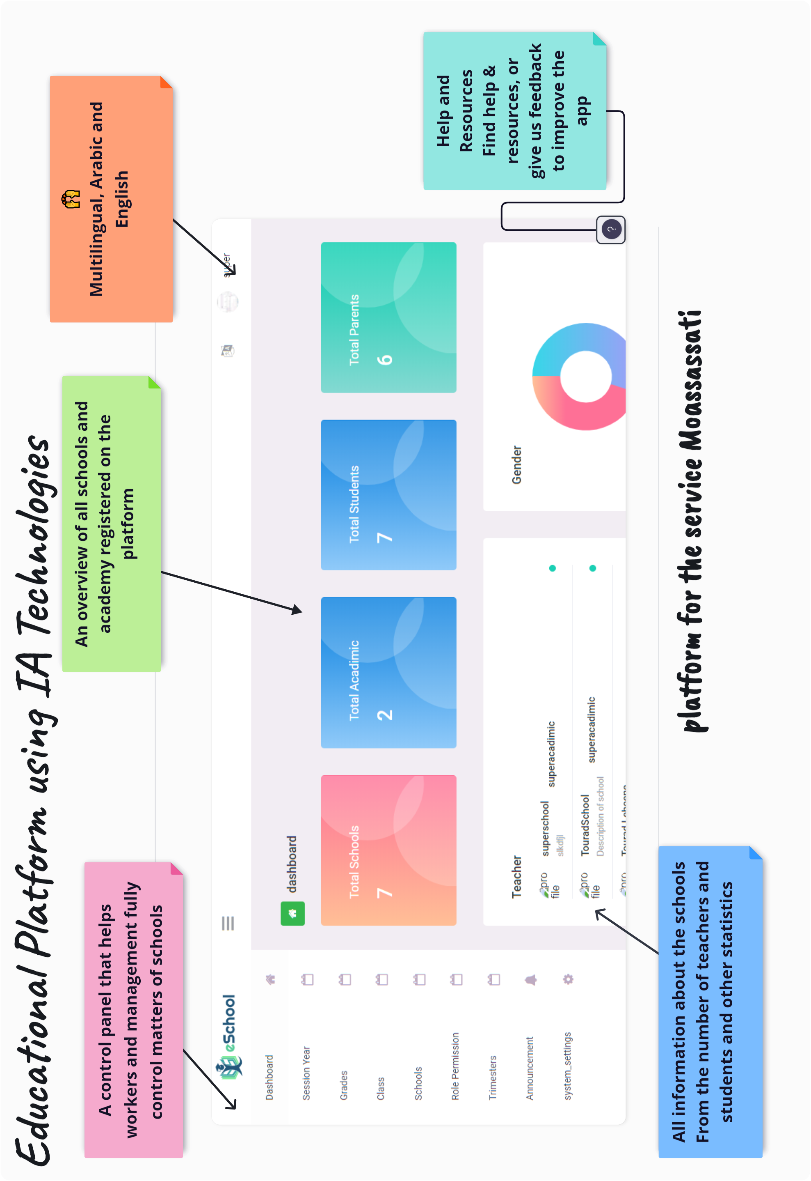

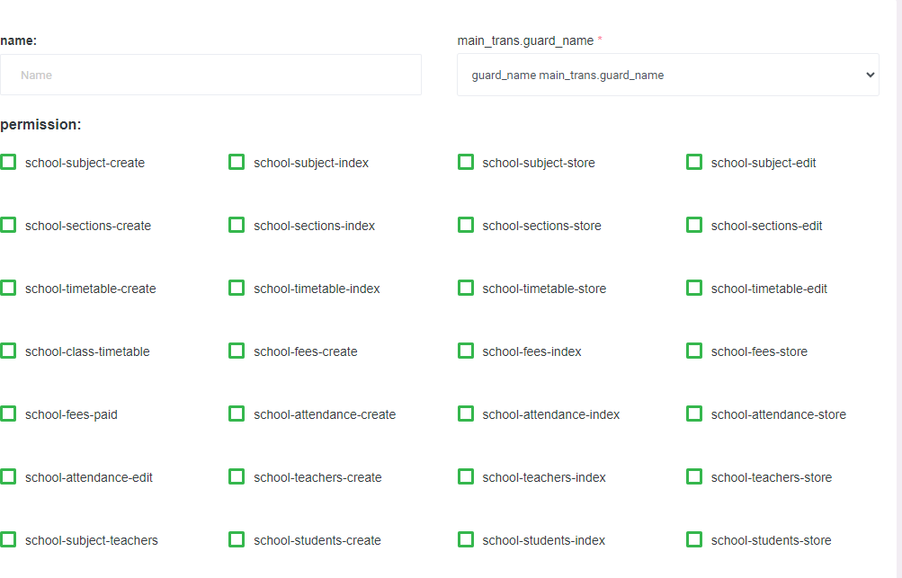

Figure 5.15: Permissions

Moassasti platform is designed to manage various aspects of school administration, providing a comprehensive set of tools for teachers, administrators, and school staff.

One of the core features of Moassasti is its robust permission management system, which allows granular control over user access to different functionalities.

This ensures that users only have access to the features and data that are relevant to their roles.

* In Moassasti, permissions are categorized by specific actions that can be performed on dif- ferent entities within the platform, such as subjects, sections, timetables, fees, attendance, teachers, and students.

For instance, permissions can be set to create, index, store, edit, and delete records related to these entities. This fine-grained control is crucial for maintaining data security and integrity, ensuring that only authorized personnel can perform certain actions.

**Laravel Permission Package:**

Moassasti platform leverages the Laravel framework’s permission package, a powerful and flex- ible tool for managing roles and permissions.

The Laravel permission package allows developers to define roles and assign them to users, along with specific permissions that control access to various parts of the application. [16]

The permission management system in Moassasti platform, powered by the Laravel permission package, provides a robust and flexible way to control user access to different functionali- ties.

This system enhances security, ensures data integrity, and allows for the efficient administration of school operations.

By leveraging the capabilities of the Laravel framework, Moassasti can offer a tailored experience to its users, ensuring that each individual can perform their duties effectively and securely.

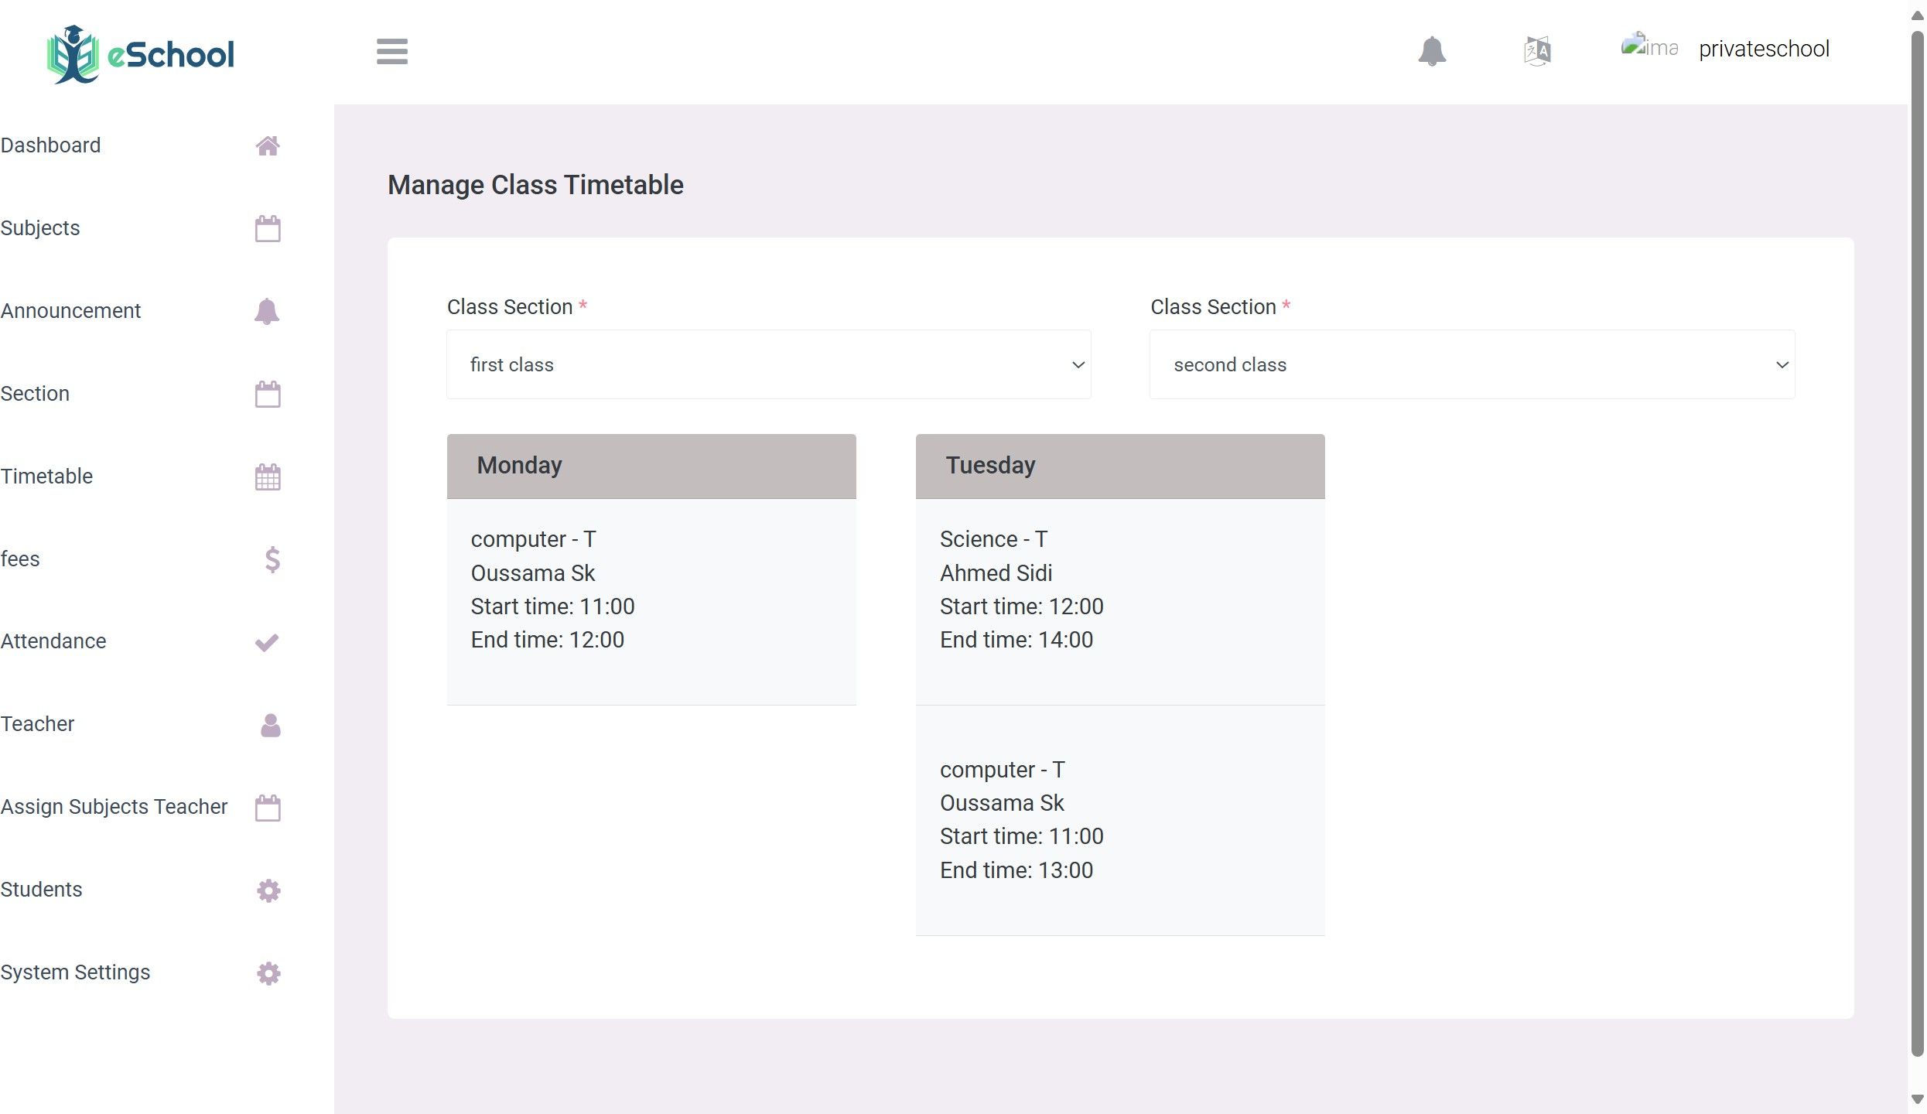

Figure 5.16: Scheduling for classes

as we see in Figure 5.16the administrative official creates a time schedule that is sent to teachers and students, all of us according to the schedule that concerns him

* + - 1. **Deploying**

Deploying a Laravel website involves setting up the server, configuring the environment, and ensuring all dependencies and configurations are in place. Choosing Hostinger for deploying our Laravel application offers a range of compelling benefits that align perfectly with our devel- opment and operational needs. Hostinger provides robust and scalable hosting solutions that are cost-effective, making it an ideal choice for both startups and established enterprises.

Their hosting plans come with ample storage, bandwidth, and a user-friendly control panel (hPanel), simplifying the deployment and management of our application. [17]

Hostinger’s support for the latest PHP versions and Laravel framework ensures compatibility and optimal performance.

Additionally, the platform’s one-click installer, free SSL certificates, and SSH access streamline the setup process, enhancing security and ease of use. With Hostinger’s global data centers, we can ensure fast load times and a reliable user experience for our audience.

The comprehensive 24/7 customer support further adds to the reliability, ensuring that any

issues are swiftly addressed, minimizing downtime and maintaining seamless operations. Over- all, Hostinger’s blend of affordability, functionality, and excellent support makes it a standout choice for deploying and managing our Laravel application.

To deploy a Laravel application efficiently, we use the Laravel Deployer package. This package automates the deployment process, making it simpler and faster to manage our project on any server.

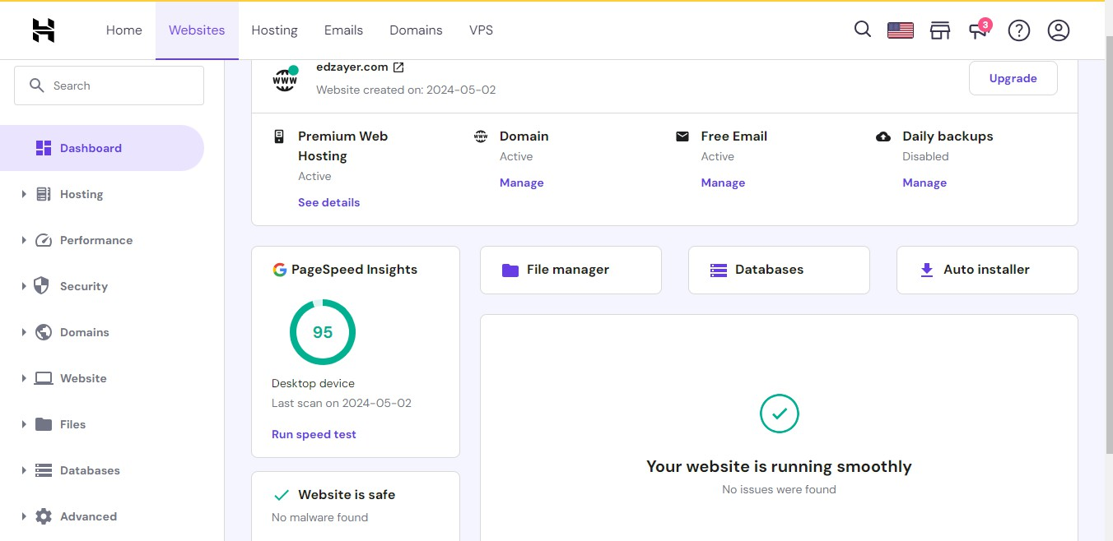

Figure 5.17: Hostinger’s hPanel for Moassasti platform

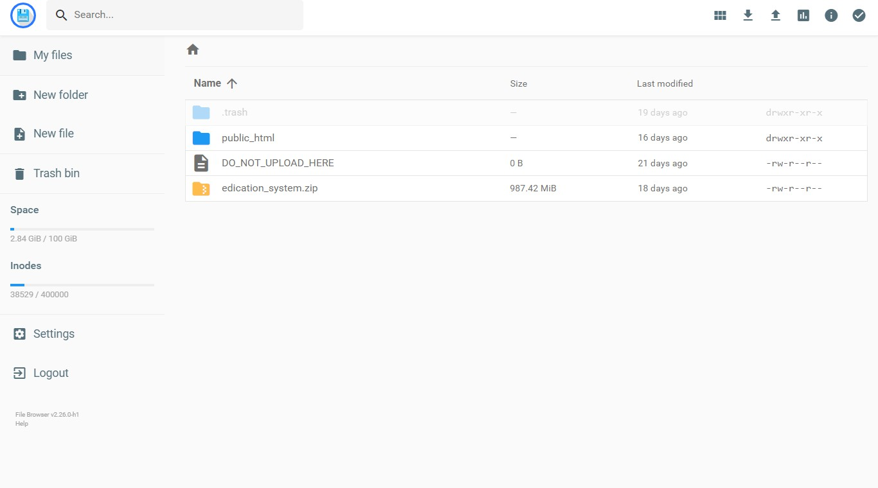

Figure 5.18: Hostinger’s hPanel for Moassasti platform

as we see in Figure 5.17we have uploaded our project to Hostinger We have an easy control panel through which we can manage the project or add anything important to the project

* + 1. **“A3rad darssek” Backend Implementation**

A3rad darssek is our virtual meeting platform, tailored specifically for educational environ- ments. It supports virtual classrooms, collaborative projects, counselling sessions, and ad- ministrative meetings. The platform is designed to be scalable and secure, ensuring reliable performance for various educational activities.

This tool enhances the learning experience by enabling seamless virtual interactions among teachers, students, and administrative staff.

* + - 1. **Infrastructures & Technologies**

Next.js is a powerful and flexible React framework that offers a variety of benefits, making it an excellent choice for building robust and high-performance web applications like the A3rad darssek platform.



Figure 5.19: Next.js

For the development of the *A3rad darssek* Meeting Platform, we utilize the Next.js framework. Next.js offers various benefits including:

* + - * + **Server-side Rendering (SSR):** Improves initial load times and SEO.
        + **Static Site Generation (SSG):** Provides efficient content delivery.
        + **Automatic Code Splitting:** Ensures efficient asset optimization.
        + **Seamless Integration:** Works well with React and its ecosystem.

**User Authentication with Clerk**

The *Clerk* package, which is a user authentication system, is integrated into the *A3rad darssek*

platform providing the following benefits:

* + - * + Robust and secure user authentication, including support for various sign-in methods.
        + User management features, such as user profiles, roles, and permissions.
        + Seamless integration with the Next.js framework and the overall application architecture.

**Real-Time Communication with GetStream**

*GetStream*, a scalable and feature-rich chat and activity feed platform, has been leveraged to power the real-time communication and collaboration capabilities of the *A3rad darssek* Meeting Platform.

##### Usage scenarios in “A3rad darssek”

**Integration of Clerk for User Authentication and Management**

Clerk is integrated into A3rad darssek to provide robust user authentication and management features. Its benefits include:

* + - * + **Ease of Implementation:** Clerk offers an easy-to-integrate solution for handling user authentication, allowing developers to focus on building core functionalities rather than managing complex authentication flows.

**Dashboard Overview**

* + - * + **Total Users:** Displays the total number of users who have signed up for the application.
        + **Active Users:** Shows the number of users active in the current month.
        + **Sign-ups:** Number of new user registrations for the current month.
        + **Sign-ins:** Number of user sign-ins for the current month.

**Recent Activities**

* + - * + **Recent Sign-ups:** Lists the most recent user registrations along with their details.
        + **Recent Sign-ins:** Shows the recent user login activities.

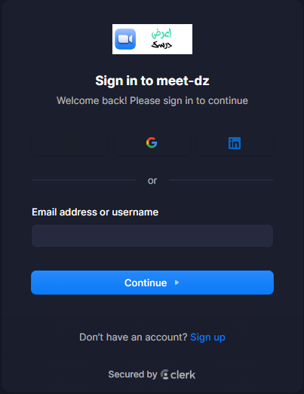

Figure 5.20: a3rad darsak login

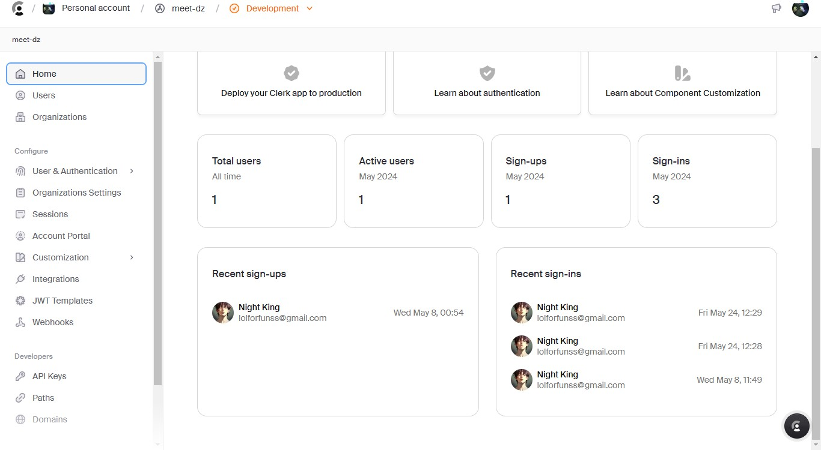

Figure 5.21: Clerk Dashboard

Figure 5.22: A3rad darssek dash bord

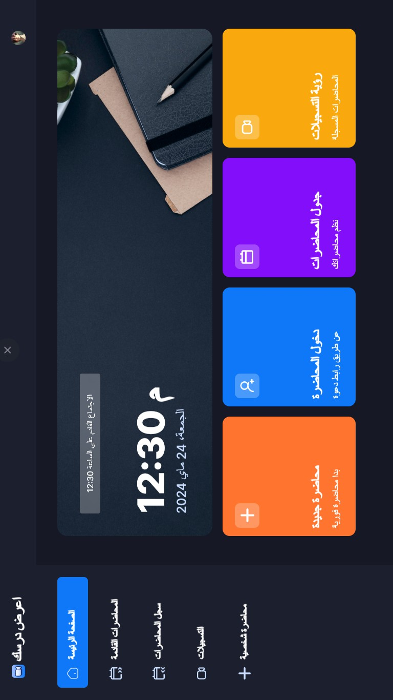

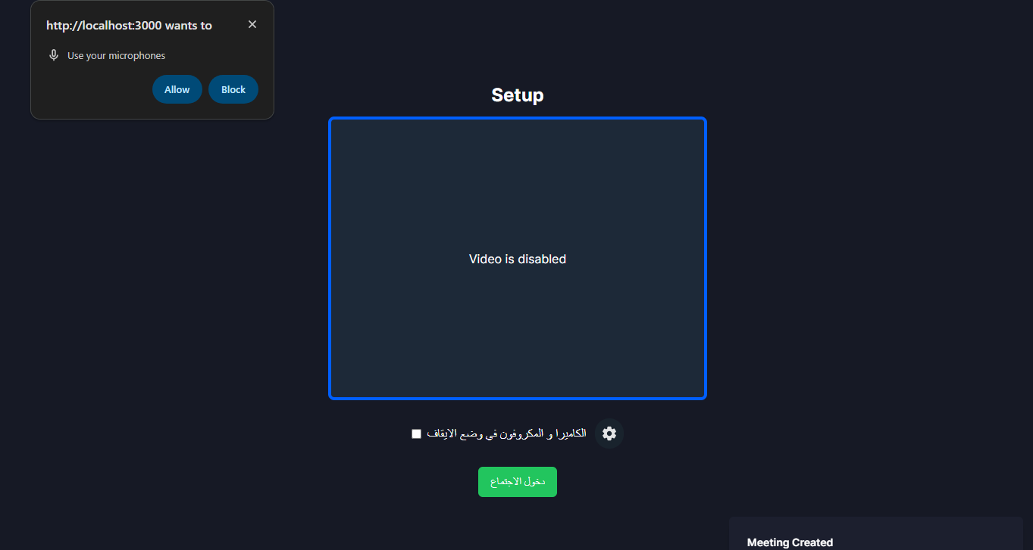

Figure 5.23: Meeting start

As shown in Figure 5.23, the teacher can open a meeting through an easy and interactive interface, with an alerts system that sends notifications to all members of the department he studies.

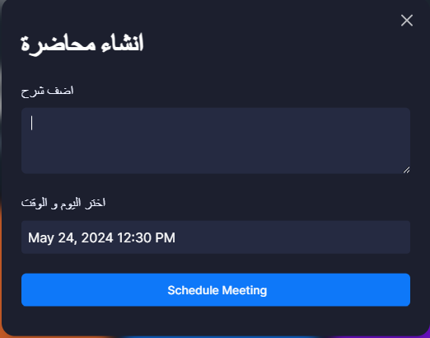

Figure 5.24: Meeting schedule

As shown in Figure 5.24,in our platform, scheduling plays a critical role in organizing educa- tional activities. Teachers can easily schedule their meetings, lessons, or courses through A3rad Darssk. The system is designed to automatically send notifications to parents and students via the Adross mobile application.

This integration ensures that all relevant parties are notified well in advance, reducing the chances of missed sessions and improving overall participation.

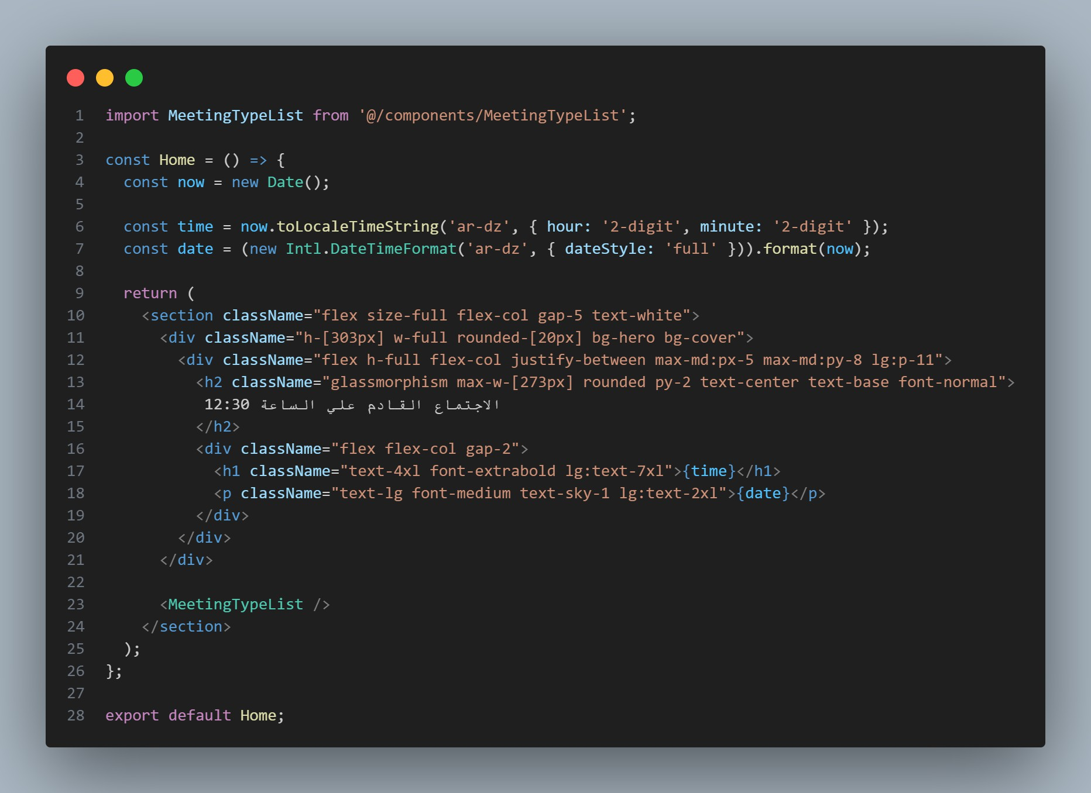

Figure 5.25: code for home page

As shown in Figure 5.25,the dashboard designed for teachers provides an easy-to-use interface that allows them to start meetings or educational sessions with their students, along with a recording system to capture these sessions for future reference.

This dashboard includes essential features that enhance the teaching experience and interaction between teachers and students.

#### Programming Platform and Technology

**Flutter Framework**

Flutter was chosen as the development framework for the Adross app due to its numerous advantages that align perfectly with

our project requirements. Flutter, an open-source UI

software development kit created by Google, allows for the creation of natively compiled applications for mobile, web, and desktop from a single codebase. Here are the key reasons for

choosing Flutter for the Adross mobile app [18]:

* **Cross-Platform Development:** Flutter enables us to write code once and deploy it across both Android and iOS platforms. This significantly reduces development time and effort compared to maintaining separate codebases for each platform.
* **High Performance:** Flutter’s architecture allows direct compilation to native ARM code for both Android and iOS, ensuring high performance and smooth user experiences.

The framework’s use of the Dart language, which compiles to native code, contributes to fast app startup times and efficient performance.

* **Consistent UI and Business Logic:** With Flutter, we can achieve a consistent look and feel across platforms while sharing business logic. This consistency is vital for providing a unified user experience, regardless of the device or operating system.
* **Hot Reload Feature:** Flutter’s hot reload feature allows developers to instantly see the results of changes in the code without restarting the entire app. This accelerates the development process and facilitates rapid iteration, making it easier to experiment and fix bugs on the fly.
* **Rich Set of Widgets:** Flutter provides a comprehensive library of pre-designed widgets that adhere to Material Design and Cupertino (iOS) standards. This allows for the creation of visually appealing and highly responsive user interfaces with minimal effort.
* **Strong Community and Support:** Flutter boasts a growing community of developers and a wealth of resources, including extensive documentation, tutorials, and third-party libraries. This support ecosystem is invaluable for troubleshooting, learning, and enhanc- ing the app with new features.
* **Future-Proofing:** As a Google-backed framework, Flutter is continuously evolving with regular updates and improvements. This commitment to ongoing development ensures that the Adross app will benefit from the latest innovations and stay up-to-date with industry standards.

**Python and Libraries Used**

* **Data Manipulation and Analysis:** Pandas is excellent for handling and analyzing structured data. It provides data structures like DataFrame, which make it easy to manipulate data.
* **Data Cleaning:** It offers robust tools for cleaning and preparing data for analysis. [19]
* **Integration:** Pandas integrates well with other libraries in the Python ecosystem, such as NumPy and Matplotlib.pandas
* **Machine Learning:** Scikit-learn provides simple and efficient tools for data mining and data analysis.
* **Preprocessing:** It includes a wide range of algorithms for preprocessing, like the TF-IDF vectorizer used in the algorithm.
* **Modeling:** Offers various algorithms for classification, regression, clustering, and more.
* **Performance:** It is built on top of NumPy, SciPy, and Matplotlib, ensuring high per- formance and compatibility with these libraries.

**TF-IDF Vectorizer:** Converts text data into numerical vectors based on the importance of words, which is useful for text analysis and similarity computations.

**Cosine Similarity:** Measures the cosine of the angle between two non-zero vectors, which is useful for calculating similarity between texts.

#### “Adross” Backend Implementation

In the modern educational ecosystem, effective communication between schools, students, and parents is crucial. To bridge this gap and enhance the overall educational experience, we have developed two complementary mobile applications: **Adross** and **Adross Guardian**. These apps serve distinct purposes but work together seamlessly to provide a comprehensive solution for educational management and parental involvement.

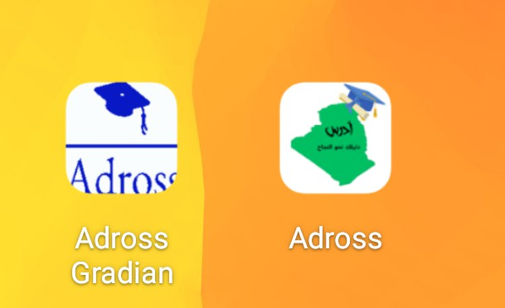

Figure 5.26: Adross Apps

##### Adross App

Adross app is designed for students, providing them with a robust platform to manage their educational activities.

This app offers a range of features tailored to meet the needs of students:

* + - * + Class Schedules
        + Homework and Assignments
        + Notifications
        + Resource Access

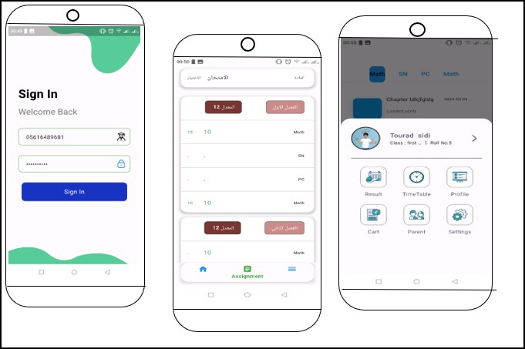

Figure 5.27: Adross app is designed for students

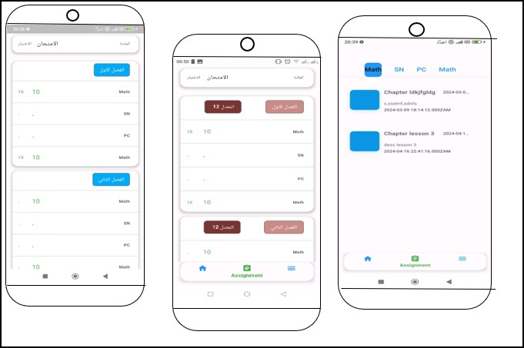

Figure 5.28: Adross app is designed for students

##### Adross Guardian App

Adross Guardian app is specifically designed for parents, enabling them to stay informed and involved in their children’s education.

This app ensures that parents have the necessary tools to support and monitor their child’s academic progress:

* + - * + **Real-Time Updates:** Parents receive real-time notifications about their child’s aca- demic activities, including attendance, grades, and behavioral reports.
        + **Scheduling:** The app provides parents with access to their child’s class schedules and important school events, ensuring they are always informed about their child’s academic commitments.
        + **Homework and Assignments:** Parents can view their child’s homework and assign- ment details, helping them to support and encourage their child’s educational efforts.
        + **Communication:** The app facilitates direct communication between parents and teach- ers, allowing for quick and effective resolution of any concerns or issues.
        + **Performance Tracking:** Parents can monitor their child’s academic performance through detailed reports and analytics, enabling them to take proactive steps to support their child’s education.

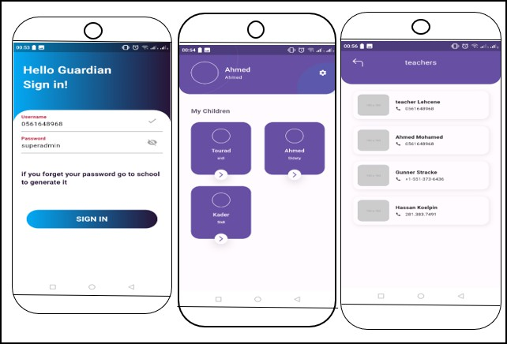

Figure 5.29: Adross Guardian app designed for parents

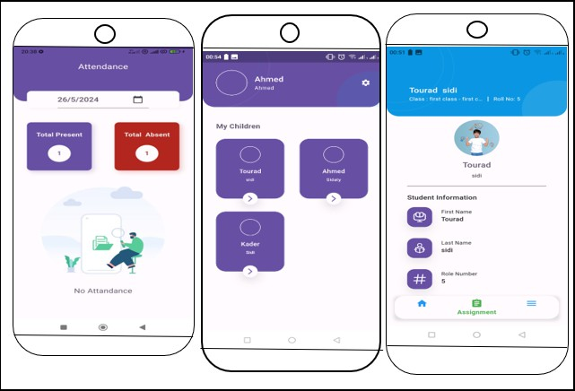

Figure 5.30: Adross Guardian app designed for parents

#### 3ink 3la Weldek Service

3ink 3la Weldek service is a feature of the Moassasti platform designed to enhance communica- tion and engagement between schools and parents.this service ensures that parents are promptly notified about their child’s attendance and any pertinent academic updates.

* **Real-Time Notifications:**
  + Parents receive instant notifications regarding their child’s attendance status.
  + Notifications include details on whether the student is present or absent for the day.
* **Daily Reports:**
  + The platform generates daily attendance reports.
  + Reports are sent to parents, ensuring they have a clear understanding of their child’s attendance patterns.
* **User-Friendly Interface:**
  + The platform is designed with an intuitive and user-friendly interface.
  + Parents can easily navigate and access attendance information.
* **Automated Alerts:**
  + Automated alerts are sent to parents when their child is marked absent.
  + This feature ensures that parents are immediately aware of any absences and can take necessary actions.

**Benefits for Parents**

* **Increased Awareness:** Parents are kept informed about their child’s attendance, helping them stay engaged with their child’s education.
* **Timely Interventions:** Immediate notifications enable parents to address any atten- dance issues promptly.
* **Peace of Mind:** Knowing they will be alerted about any absences, parents can feel more secure about their child’s well-being at school.

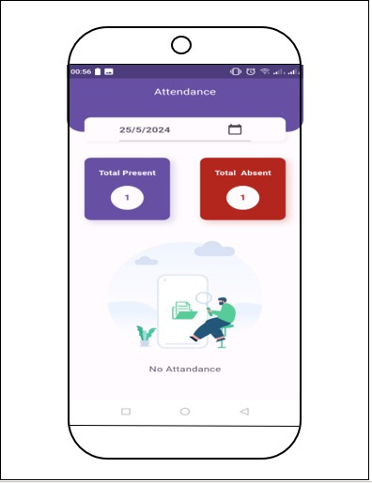

Figure 5.31: 3ink 3la Weldek Service

This interface enables the student’s guardian to know the number of his son’s absences, daily or the number of hours he was absent per day,in an easy-to-understand format, it can be read by anyone (see Figure 5.31).

We also see here that the father was alerted by the application that his son was absent at such and such time on such and such day ,The system also alerts father of the absence of teachers or changes in the time of lessons and classes (see Figure 5.32).

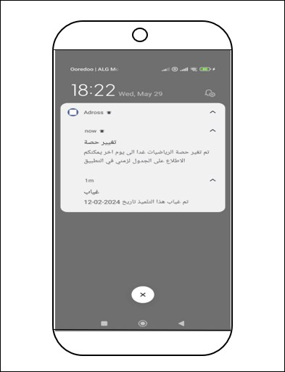

Figure 5.32: Alerts and notifications system

#### Saned Weldek Services

##### Web Scraping from DZ Exam and Ency-Education

Web scraping involves the extraction of data from websites using automated scripts,this data can be collected for various purposes, such as analysis, storage, and integration into other systems. In the context of our platform, we utilize web scraping to gather educational data from DZ Exam and Ency-Education. This process is not only automated but also scheduled to ensure regular updates and freshness of the information.

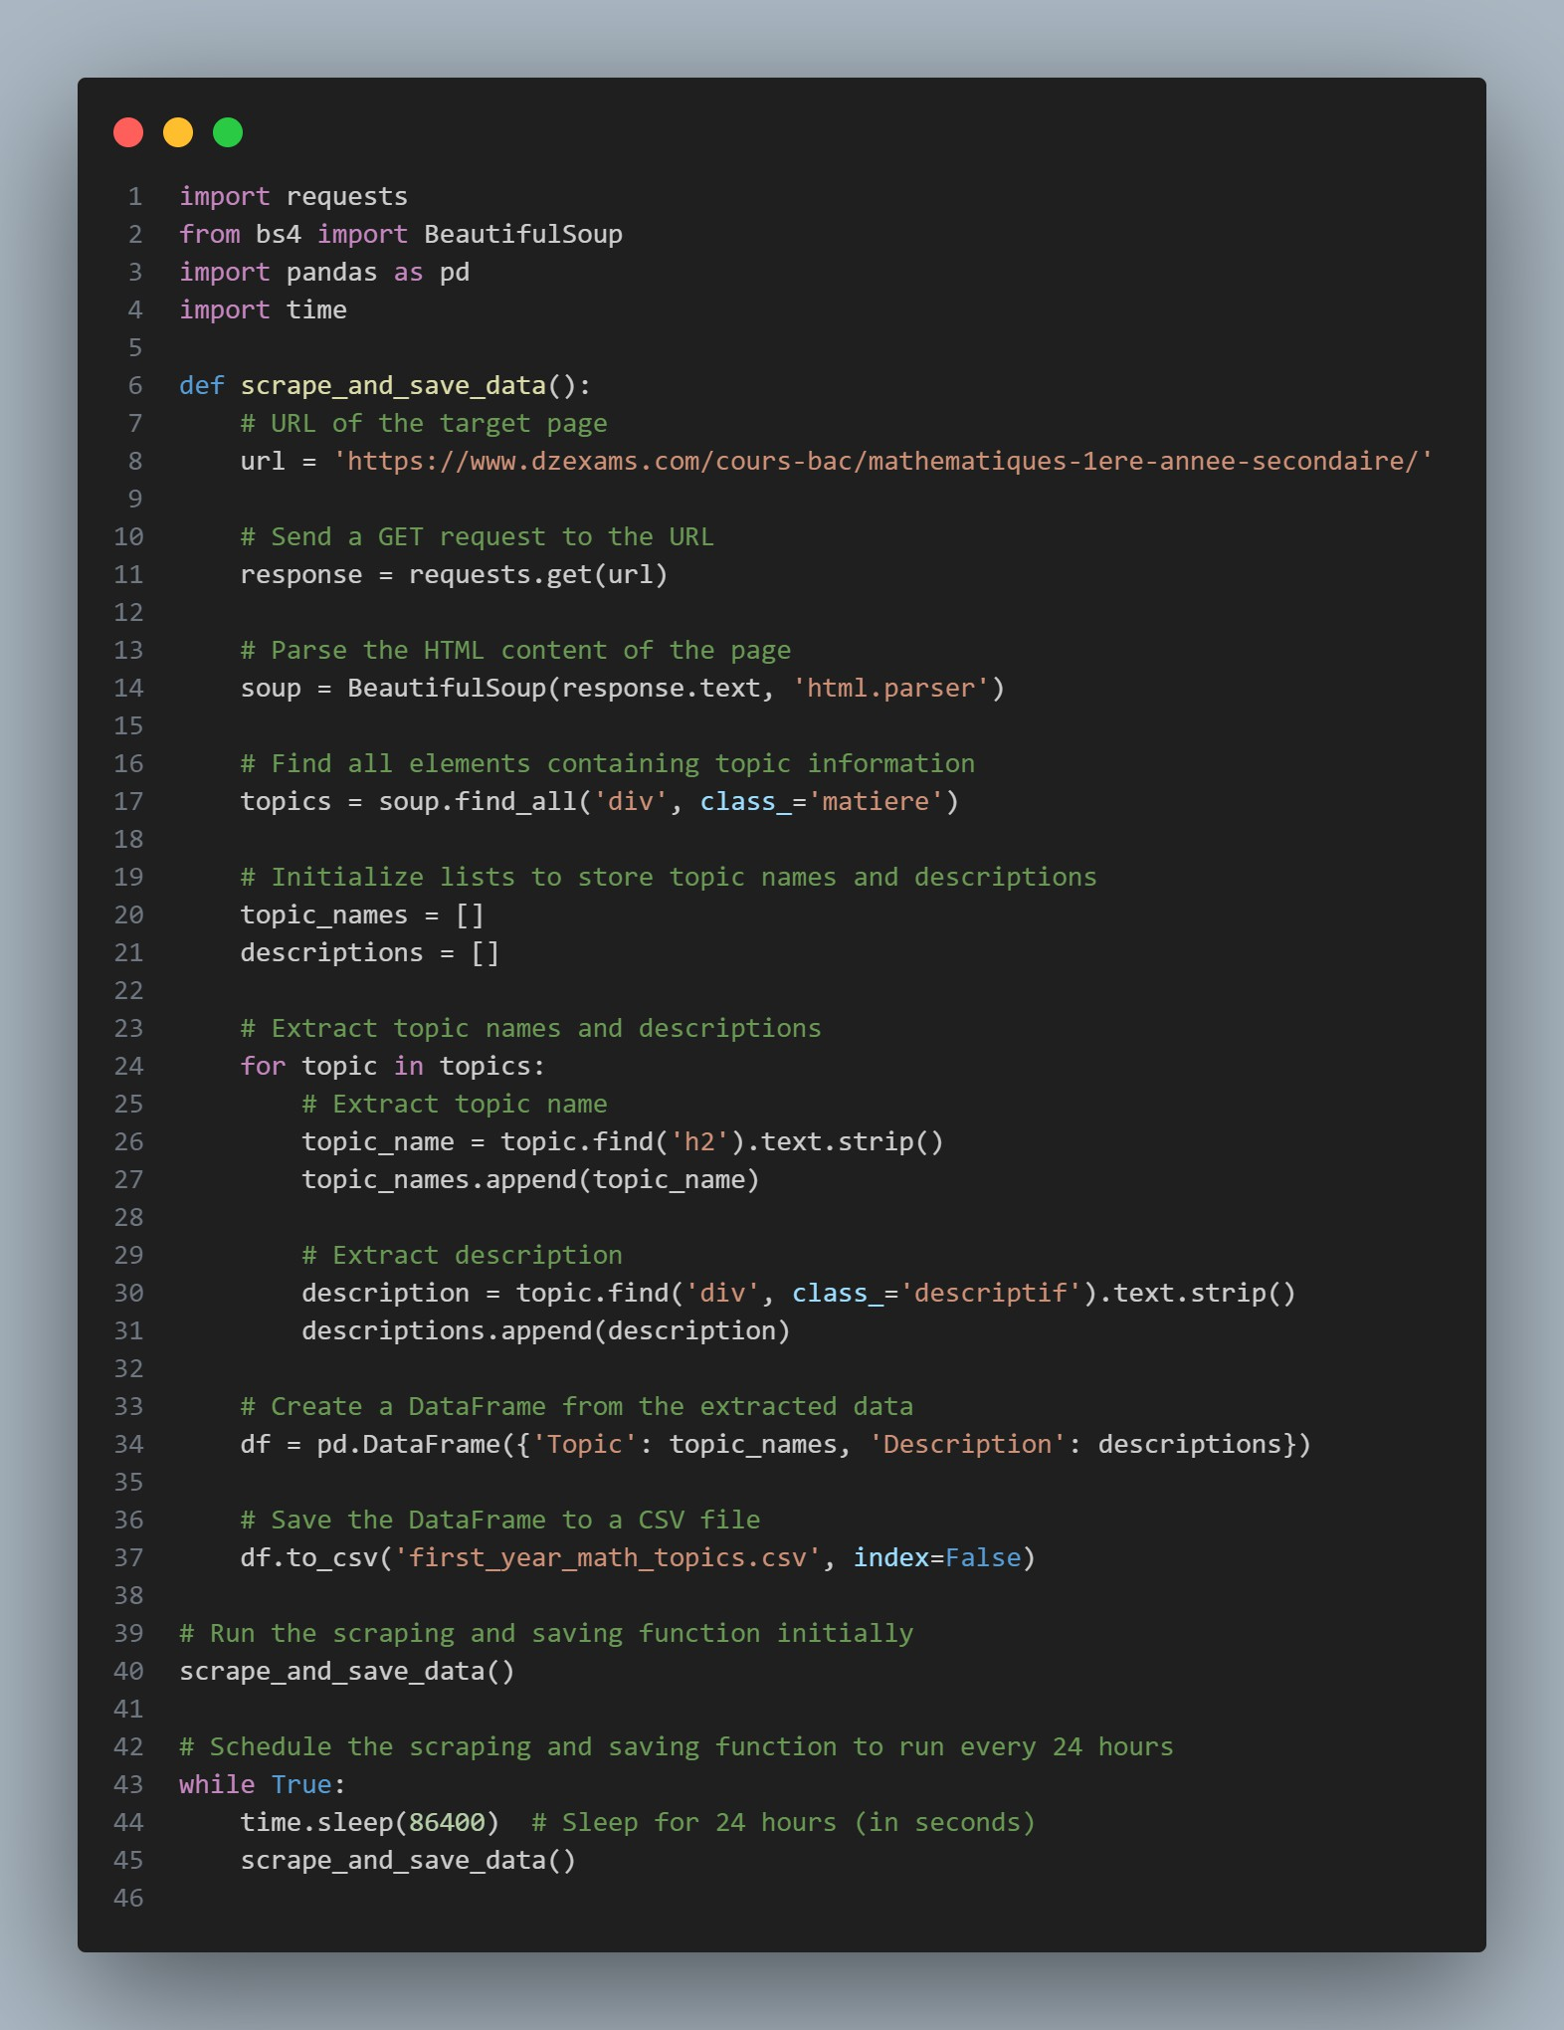

Figure 5.33: Web scraping code

Figure 5.34: Data base from web scraping

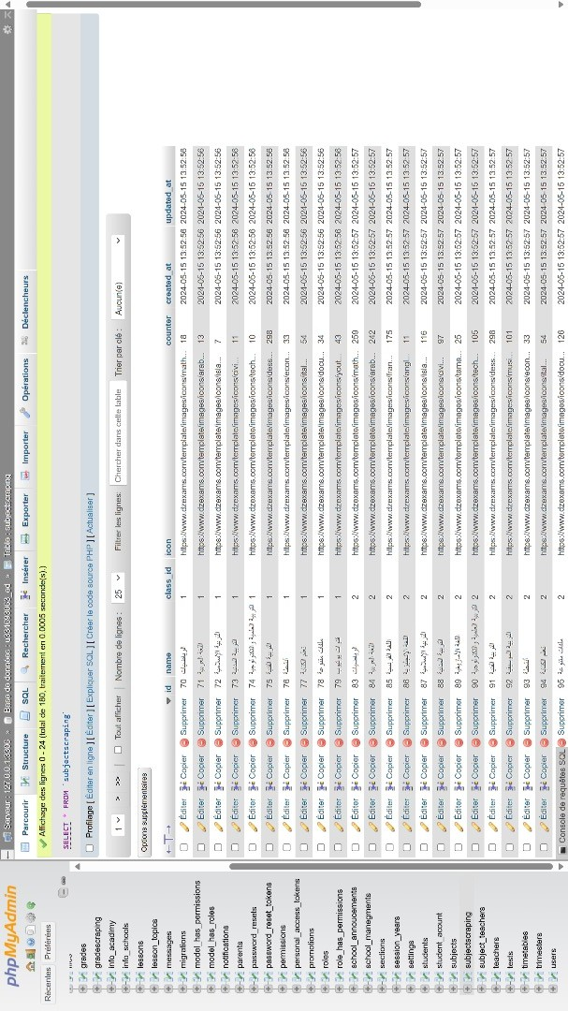

**Recommendation Function**

* + - * + The recommend_topics_with_schedule function takes the user input (current topic) and the number of days before the exam or lesson.
        + It calculates the date of the exam or lesson based on the current date and the days_before_exam parameter.
        + The function then filters the topics that are scheduled before the calculated exam date.
        + It identifies the index of the user input topic and calculates the similarity scores with other topics.
        + The function sorts these scores and retrieves the top three most similar topics to recom- mend.

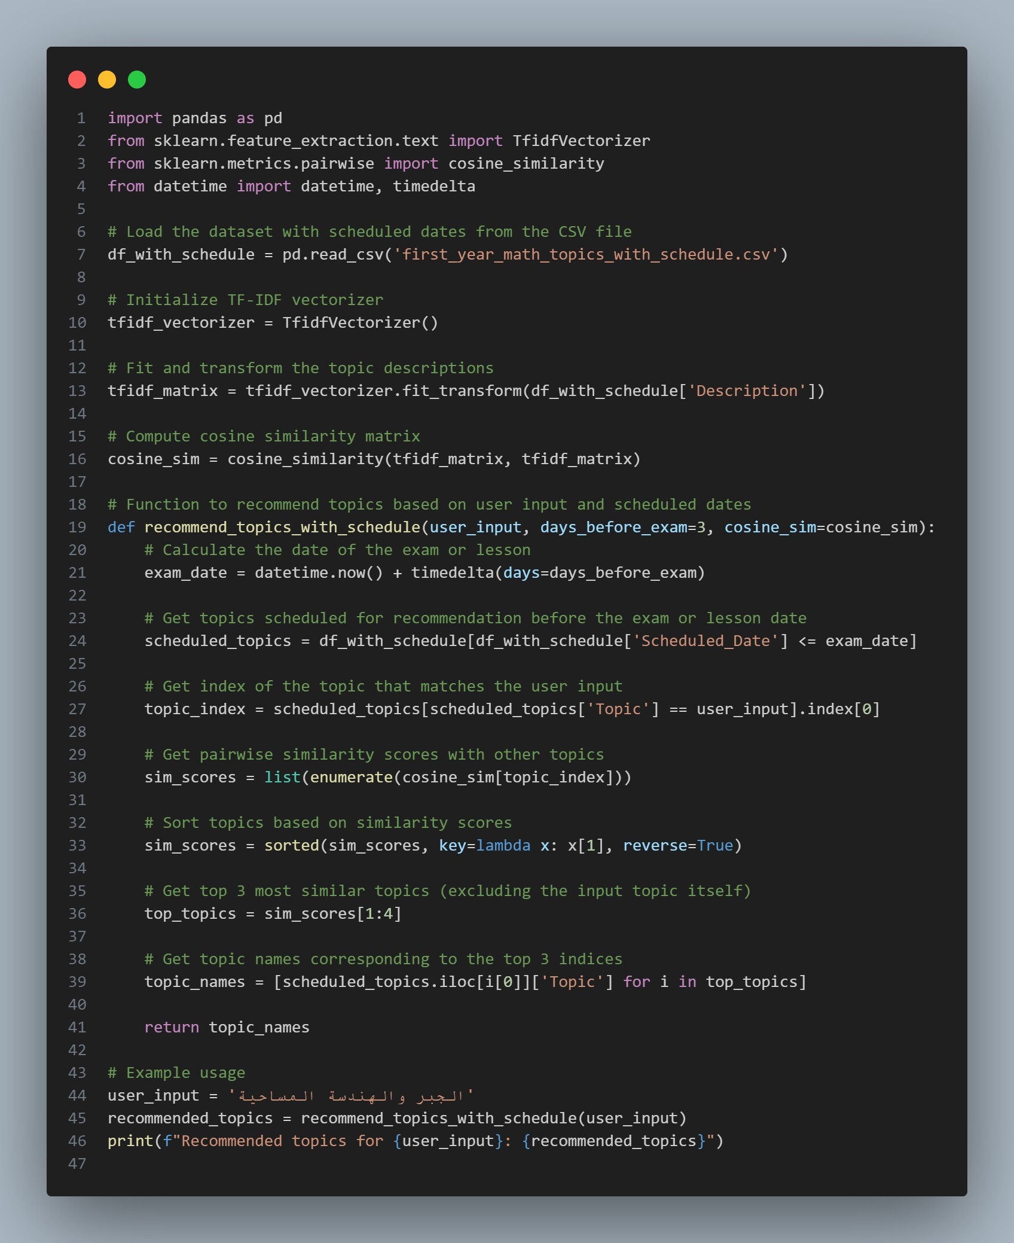

Figure 5.35: recommend system code

As we see here, an alert and notification was sent to the student’s guardian and the student that there was a recommendation for a specific lesson three days before the exam(see Figure 5.36).

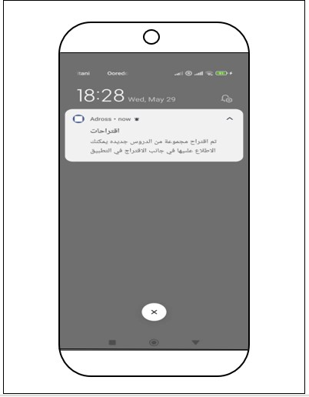

Figure 5.36: Recommendations and notifications system

As we see here,we have a section in the application that contains all the suggestions and recommendations for lessons and exams that the student can view at any time and whenever he wants. (see Figure 5.37).

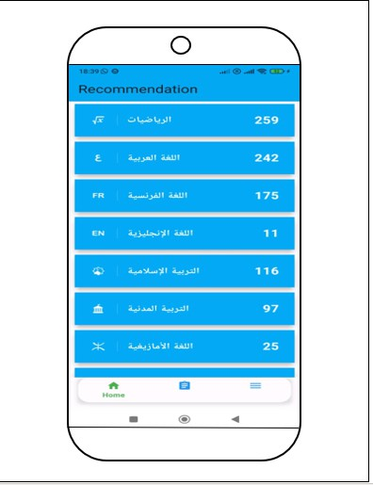

Figure 5.37: Cours recommended

### Conclusion

The implementation and development of Moassasti and A3rad darssek represent a significant advancement in the management and operational capabilities of educational institutions.

By integrating these tools, we aim to streamline administrative processes, enhance communi- cation, and provide a secure, efficient, and user-friendly environment for both educators and students. Adross is designed to significantly enhance the educational experience for Algerian students and their families.

It promotes digital literacy by integrating modern technology into the education system and providing access to a wide range of digital educational resources.

The app facilitates parental involvement by offering real-time updates on their child’s atten- dance, grades, and school announcements, encouraging active participation in the learning process.

Personalized learning recommendations, powered by AI, help address individual student needs, while the app’s focus on security and data privacy ensures a safe environment for all users

Appendix

### Database Tables

|  |  |  |
| --- | --- | --- |
| **Column Name** | **Data Type** | **Description** |
| id | bigint(20) unsigned | Unique identifier for the session year |
| name | varchar(255) | Name of the session year |
| default | tinyint(4) | Indicates if this is the default session year |
| start_date | date | Start date of the session year |
| end_date | date | End date of the session year |
| created_at | timestamp | Timestamp when the record was created |
| updated_at | timestamp | Timestamp when the record was last updated |
| deleted_at | timestamp | Timestamp when the record was deleted (soft delete) |

Table 5.1: Table: session_years

|  |  |  |
| --- | --- | --- |
| **Column Name** | **Data Type** | **Description** |
| id | bigint(20) unsigned | Unique identifier for the lesson topic |
| lesson_id | int(11) | ID of the lesson this topic is associated with |
| name | varchar(128) | Name of the topic |
| description | varchar(1024) | Description of the topic |
| type | varchar(255) | Type/category of the topic |
| created_at | timestamp | Timestamp when the record was created |
| updated_at | timestamp | Timestamp when the record was last updated |
| deleted_at | timestamp | Timestamp when the record was deleted (soft delete) |

Table 5.2: Table: lesson_topics

100

|  |  |  |
| --- | --- | --- |
| **Column Name** | **Data Type** | **Description** |
| id | bigint(20) unsigned | Unique identifier for the announcement |
| title | varchar(128) | Title of the announcement |
| description | varchar(255) | Description of the announcement |
| section_id | varchar(255) | ID of the section this announcement is related to |
| subject_id | varchar(255) | ID of the subject this announcement is related to |
| table_type | varchar(255) | Type of table |
| table_id | bigint(20) unsigned | ID of the related table |
| session_year | int(11) | Session year associated with the announcement |
| school_id | int(11) | ID of the school |
| created_at | timestamp | Timestamp when the record was created |
| updated_at | timestamp | Timestamp when the record was last updated |
| deleted_at | timestamp | Timestamp when the record was deleted (soft delete) |

Table 5.3: Table: announcements

|  |  |  |
| --- | --- | --- |
| **Column Name** | **Data Type** | **Description** |
| id | bigint(20) unsigned | Unique identifier for the file |
| modal_type | varchar(255) | Type of the model the file is related to |
| modal_id | bigint(20) unsigned | ID of the related model |
| file_name | varchar(1024) | Name of the file |
| file_thumbnail | varchar(1024) | Thumbnail of the file |
| type | tinytext | Type of file |
| file_url | varchar(1024) | URL of the file |
| created_at | timestamp | Timestamp when the record was created |
| updated_at | timestamp | Timestamp when the record was last updated |

Table 5.4: Table: files

|  |  |  |
| --- | --- | --- |
| **Column Name** | **Data Type** | **Description** |
| id | bigint(20) unsigned | Unique identifier for the fee payment |
| fees_class_id | int(11) | ID of the fee class |
| student_id | tinyint(4) | ID of the student who made the payment |
| payment_transaction_id | varchar(255) | Transaction ID for the payment |
| is_fully_paid | tinyint(4) | Indicates if the payment is fully paid |
| month | varchar(255) | Month of the payment |
| amount | int(11) | Amount paid |
| school_id | varchar(255) | ID of the school |
| session_year_id | int(11) | Session year related to the payment |
| created_at | timestamp | Timestamp when the record was created |
| updated_at | timestamp | Timestamp when the record was last updated |
| deleted_at | timestamp | Timestamp when the record was deleted |

Table 5.5: Table: fee_paids

|  |  |  |
| --- | --- | --- |
| **Column Name** | **Data Type** | **Description** |
| id | bigint(20) unsigned | Unique identifier for the classroom |
| name | longtext | Name of the classroom |
| status | int(11) | Status of the classroom |
| grade_id | int(11) | ID of the grade |
| class_id | int(11) | ID of the class |
| notes | text | Additional notes about the classroom |
| created_at | timestamp | Timestamp when the record was created |
| updated_at | timestamp | Timestamp when the record was last updated |

Table 5.6: Table: classrooms

|  |  |  |
| --- | --- | --- |
| **Column Name** | **Data Type** | **Description** |
| id | bigint(20) unsigned | Unique identifier for the academy management |
| name | varchar(255) | Name of the management entity |
| description | varchar(255) | Description of the management entity |
| address | varchar(255) | Address of the management entity |
| image | varchar(255) | Image related to the management entity |
| email | varchar(255) | Email of the management entity |
| created_at | timestamp | Timestamp when the record was created |
| updated_at | timestamp | Timestamp when the record was last updated |

Table 5.7: Table: academy_managements

|  |  |  |
| --- | --- | --- |
| **Column Name** | **Data Type** | **Description** |
| id | bigint(20) unsigned | Unique identifier for the student account |
| username | varchar(255) | Username for the student |
| password | varchar(255) | Password for the student |
| student_id | int(11) | ID of the student |
| token | varchar(250) | Authentication token |
| status | varchar(255) | Status of the student account |
| created_at | timestamp | Timestamp when the record was created |
| updated_at | timestamp | Timestamp when the record was last updated |

Table 5.8: Table: student_account

|  |  |  |
| --- | --- | --- |
| **Column Name** | **Data Type** | **Description** |
| id | bigint(20) unsigned | Unique identifier for the promotion |
| created_at | timestamp | Timestamp when the record was created |
| updated_at | timestamp | Timestamp when the record was last updated |

Table 5.9: Table: promotions

|  |  |  |
| --- | --- | --- |
| **Column Name** | **Data Type** | **Description** |
| id | bigint(20) unsigned | Unique identifier for the notification |
| type | varchar(255) | Type of notification |
| notifiable_type | varchar(255) | The type of model that is being notified |
| notifiable_id | bigint(20) unsigned | The ID of the model that is being notified |
| data | text | Data related to the notification |
| read_at | timestamp | Timestamp when the notification was read |
| created_at | timestamp | Timestamp when the record was created |
| updated_at | timestamp | Timestamp when the record was last updated |

Table 5.10: Table: notifications

|  |  |  |
| --- | --- | --- |
| **Column Name** | **Data Type** | **Description** |
| id | bigint(20) unsigned | Unique identifier for the subject teacher |
| class_section_id | int(11) | ID of the class section |
| subject_id | int(11) | ID of the subject |
| teacher_id | int(11) | ID of the teacher |
| school_id | int(11) | ID of the school |
| session_year | int(11) | ID of the session year |
| status | varchar(255) | Status of the subject teacher |
| created_at | timestamp | Timestamp when the record was created |
| updated_at | timestamp | Timestamp when the record was last updated |

Table 5.11: Table: subject_teachers

|  |  |  |
| --- | --- | --- |
| **Column Name** | **Data Type** | **Description** |
| id | bigint(20) unsigned | Unique identifier for the attendance |
| student_id | int(11) | ID of the student |
| session_year | int(11) | ID of the session year |
| school_id | int(11) | ID of the school |
| section_id | int(11) | ID of the section |
| timetable_id | int(11) | ID of the timetable |
| type | tinyint(4) | Type of attendance (e.g., present, absent) |
| date | date | Date of the attendance |
| created_at | timestamp | Timestamp when the record was created |
| updated_at | timestamp | Timestamp when the record was last updated |

Table 5.12: Table: attendances

|  |  |  |
| --- | --- | --- |
| **Column Name** | **Data Type** | **Description** |
| id | bigint(20) unsigned | Unique identifier for the school announcement |
| title | varchar(255) | Title of the announcement |
| description | varchar(255) | Description of the announcement |
| image | varchar(255) | Image related to the announcement |
| model | varchar(255) | Model related to the announcement |
| session_year_id | int(11) | ID of the session year |
| school_id | int(11) | ID of the school |
| created_at | timestamp | Timestamp when the record was created |
| updated_at | timestamp | Timestamp when the record was last updated |
| deleted_at | timestamp | Timestamp when the record was deleted (soft delete) |

Table 5.13: Table: school_announcements

|  |  |  |
| --- | --- | --- |
| **Column Name** | **Data Type** | **Description** |
| id | bigint(20) unsigned | Unique identifier for the school management |
| name | varchar(255) | Name of the school management entity |
| description | varchar(255) | Description of the school management entity |
| address | varchar(255) | Address of the school management entity |
| image | varchar(255) | Image related to the school management entity |
| email | varchar(255) | Email of the school management entity |
| created_at | timestamp | Timestamp when the record was created |
| updated_at | timestamp | Timestamp when the record was last updated |

Table 5.14: Table: school_managements

|  |  |  |
| --- | --- | --- |
| **Column Name** | **Data Type** | **Description** |
| id | bigint(20) unsigned | Unique identifier for the fee class |
| class_section_id | int(11) | ID of the class section |
| amount | double(8,2) | Amount for the fee class |
| session_year_id | int(11) | ID of the session year |
| created_at | timestamp | Timestamp when the record was created |
| updated_at | timestamp | Timestamp when the record was last updated |

Table 5.15: Table: feesclasses

|  |  |  |
| --- | --- | --- |
| **Column Name** | **Data Type** | **Description** |
| id | bigint(20) unsigned | Unique identifier for the subject |
| name | varchar(255) | Name of the subject |
| code | varchar(255) | Code of the subject |
| image | varchar(255) | Image related to the subject |
| type | varchar(255) | Type/category of the subject |
| notes | varchar(255) | Additional notes about the subject |
| grade_id | int(11) | ID of the grade |
| class_id | varchar(255) | ID of the class |
| school_id | int(11) | ID of the school |
| created_at | timestamp | Timestamp when the record was created |
| updated_at | timestamp | Timestamp when the record was last updated |

Table 5.16: Table: subjects

|  |  |  |
| --- | --- | --- |
| **Column Name** | **Data Type** | **Description** |
| id | bigint(20) unsigned | Unique identifier for the trimester |
| created_at | timestamp | Timestamp when the record was created |
| updated_at | timestamp | Timestamp when the record was last updated |
| notes | text | Notes about the trimester |
| status | int(11) | Status of the trimester |

Table 5.17: Table: trimesters

## Conclusion

**General conclusion**

General conclusion During our internship and precisely in this report, we have approached the Algerian education sector and we have taken a deeper dive into the world of e-learning and m-learning applications, addressing the lacunae in the existing solutions and meeting the evolving needs of the Algerian education sector. These needs could be reached by leveraging a comprehensive integration of web-based and mobile components, virtual learning tools, parent- school collaboration, and AI-powered personalized recommendations. As a result, by addressing the specific requirements of the education sector and providing innovative solutions, the fruit of this report was the realization and production of a comprehensive framework called “Darris Bi Dhakaa” offering four tools.

The first one was an Institutional Learning Management platform *Moassassati*. The second was a Virtual Meeting Platform *A3rad Darssek*. Otherwise, the third one and the fourth one are *3inek 3la Weldek* and *Saned Weldek*. *3inek 3la Weldek*. These tools can be considered a gain for the Algerian education sector.

Finally, this present work has given us extensive experience in exchanging our knowledge with representatives in the educational field, including directors and inspectors. Truly, it is a vast, complex, but fascinating field. This is why our work is far from exhaustive.

106

## Bibliography

1. S. Al-Heeh and M. A. Sara, “Reviewing the recurrent restrictions of e-learning among palestinian students: A case study of pau,” *Journal of Palestine Ahliya University for* *Research and Studies*, vol. 2, no. 2, pp. 19–31, 2023.
2. C. H. Liu, “The comparison of learning effectiveness between traditional face-to-face learn- ing and e-learning among goal-oriented users,” in *6th International conference on digital* *content, multimedia technology and its applications*, pp. 255–260, IEEE, August 2010.
3. E. P. Nugroho, K. Hidayat, and E. A. Nurdin, “Development of e-learning-based blended learning to increase student learning motivation during a pandemic,” *APTISI Transactions* *on Management*, vol. 7, no. 2, pp. 160–169, 2023.
4. M. Ouadoud, N. Rida, and T. Chafiq, “Overview of e-learning platforms for teaching and learning,” *Int. J. Recent Contributions Eng. Sci. IT*, vol. 9, no. 1, pp. 50–70, 2021.
5. M. A. Almaiah, “Retraction note: Acceptance and usage of a mobile information system services in university of jordan,” *Education and Information Technologies*, vol. 28, no. 9,

p. 12337, 2023.

1. I. Portugal, P. Alencar, and D. Cowan, “The use of machine learning algorithms in recom- mender systems: a systematic review,” *Expert Systems with Applications*, vol. 97, pp. 205– 227, 2018.
2. A. De Biasio, A. Montagna, F. Aiolli, and N. Navarin, “A systematic review of value-aware recommender systems,” *Expert Systems with Applications*, p. 120131, 2023.
3. X. Su and T. Khoshgoftaar, “A survey of collaborative filtering techniques,” *Advances in* *Artificial Intelligence*, pp. 1–19, 2009.
4. L. Mekouar, Y. Iraqi, I. Damaj, and T. Naous, “A survey on blockchain-based recommender systems: integration architecture and taxonomy,” *Computer Communications*, vol. 187,

pp. 1–19, 2022.

1. J. K. Tarus, Z. Niu, and G. Mustafa, “Knowledge-based recommendation: a review of ontology-based recommender systems for e-learning,” *Artificial Intelligence Review*, vol. 50, no. 1, pp. 21–48, 2018.
2. S. Chacon and B. Straub, *Pro Git*. Apress, 2014.

107

BIBLIOGRAPHY

1. C. Date, *An Introduction to Database Systems*. Addison-Wesley, 2004.
2. “Laravel.” <https://laravel.com/>, 2022. PHP Framework.
3. Oracle Corporation, *MySQL*, 2022.
4. “Laravel passport.” <https://laravel.com/docs/8.x/passport>.
5. “Laravel permissions.” <https://github.com/spatie/laravel-permission>.
6. “Hostinger.” <https://www.hostinger.com/>, 2022. Web Hosting Services.
7. “Flutter.” <https://flutter.dev/>.
8. “Python.” <https://www.python.org/>.

108